UNITED STATES

SECURITIES AND EXCHANGE COMMISSION
WASHINGTON, D.C. 20549

FORM 10-Q

(Mark One)

- QUARTERLY REPORT PURSUANT TO SECTION 13 OR 15(d) OF THE SECURITIES EXCHANGE ACT OF 1934 For the quarterly period ended September 30, 2024

OR

- TRANSITION REPORT PURSUANT TO SECTION 13 OR 15(d) OF THE SECURITIES EXCHANGE ACT OF 1934 For the transition period from ____________ to ____________

Commission file number: 001-15911

Imunon, Inc.

(Exact name of Registrant as specified in its charter)

Delaware | 52-1256615
(State or other jurisdiction of |  |  | (I.R.S. Employer
incorporation or organization) |  |  | Identification Number)
 | 997 Lenox Drive, Suite 100,
 | Lawrenceville, NJ 08648
 | (Address of principal executive offices)

(609) 896-9100

(Registrant’s telephone number, including area code)

NA

(Former name, former address and former fiscal year, if changed since last report)

Securities registered pursuant to Section 12(b) of the Act

Title of each class |  | Trading symbol(s) |  | Name of each exchange on which registered
Common stock, par value $0.01 per share |  | IMNN |  | Nasdaq Capital Market

Indicate by check mark whether the Registrant (1) has filed all reports required to be filed by Section 13 or 15(d) of the Securities Exchange Act of 1934 during the preceding 12 months (or for such shorter period that the registrant was required to file such reports) and (2) has been subject to such filing requirements for the past 90 days. Yes ☒ No ☐

Indicate by check mark whether the Registrant has submitted electronically every Interactive Data File required to be submitted pursuant to Rule 405 of Regulation S-T (§232.405 of this chapter) during the preceding 12 months (or for such shorter period that the Registrant was required to submit such files). Yes ☒ No ☐

Indicate by check mark whether the Registrant is a large accelerated filer, an accelerated filer, a non-accelerated filer, a smaller reporting company or an emerging growth company. See the definitions of “large accelerated filer,” “accelerated filer,” “smaller reporting company” and “emerging growth company” in Rule 12b-2 of the Exchange Act (Check One):

Large accelerated filer ☐

Non-accelerated filer ☒

Emerging growth company ☐

Accelerated filer ☐

Smaller reporting company ☒

If an emerging growth company, indicate by check mark if the registrant has elected not to use the extended transition period for complying with any new or revised financial accounting standards provided pursuant to Section 13(a) of the Exchange Act. ☐

Indicate by check mark whether the Registrant is a shell company (as defined in Rule 12b-2 of the Exchange Act). Yes ☐ No ☒

As of November 5, 2024, the Registrant had 14,500,685 shares of common stock, $0.01 par value per share, outstanding.

 |  |  |  |  |  |  |  |  |  |  |  |  |  |  |  | IMUNON, INC.
 |  |  |  |  |  |  |  |  |  |  |  |  |  | QUARTERLY REPORT ON
 |  |  |  |  |  |  |  |  |  |  |  |  |  |  |  | FORM 10-Q
 |  |  |  |  |  |  |  |  |  |  |  |  |  | TABLE OF CONTENTS
 |  |  |  |  |  |  |  |  |  |  |  |  |  |  |  |  |  |  |  |  |  |  |  |  | Page(s)
PART I: FINANCIAL INFORMATION
Item 1. | Financial Statements
 | Condensed Consolidated Balance Sheets as of September 30, 2024 (Unaudited) and December 31, 2023 |  |  |  |  |  |  |  |  |  |  |  |  |  |  |  |  |  |  |  |  |  |  |  | 1
 | Condensed Consolidated Statements of Operations (Unaudited) for the Three and Nine Months Ended September 30, 2024 and 2023 |  |  |  |  |  |  |  |  |  |  |  |  |  |  |  |  |  |  |  |  |  |  |  | 3
 | Condensed Consolidated Statements of Comprehensive Loss (Unaudited) for the Three and Nine Months Ended September 30, 2024 and
 | 2023 |  |  |  |  |  |  |  |  |  |  |  |  |  |  |  |  |  |  |  |  |  |  |  | 4
 | Condensed Consolidated Statements of Cash Flows (Unaudited) for the Nine Months Ended September 30, 2024 and 2023 |  |  |  |  |  |  |  |  |  |  |  |  |  |  |  |  |  |  |  |  |  |  |  | 5
 | Condensed Consolidated Statements of Changes in Stockholders’ Equity (Unaudited) for the Three Months Ended September 30, 2024
 | and 2023 |  |  |  |  |  |  |  |  |  |  |  |  |  |  |  |  |  |  |  |  |  |  |  | 7
 | Condensed Consolidated Statements of Changes in Stockholders’ Equity (Unaudited) for the Nine Months Ended September 30, 2024
 | and 2023 |  |  |  |  |  |  |  |  |  |  |  |  |  |  |  |  |  |  |  |  |  |  |  | 8
 | Notes to the Condensed Consolidated Financial Statements (Unaudited) |  |  |  |  |  |  |  |  |  |  |  |  |  |  |  |  |  |  |  |  |  |  |  | 9
Item 2. Management’s Discussion and Analysis of Financial Condition and Results of Operations |  |  |  |  |  |  |  |  |  |  |  |  |  |  |  |  |  |  |  |  |  |  |  |  | 19
Item 3. Quantitative and Qualitative Disclosures about Market Risk |  |  |  |  |  |  |  |  |  |  |  |  |  |  |  |  |  |  |  |  |  |  |  |  | 35
Item 4. Controls and Procedures |  |  |  |  |  |  |  |  |  |  |  |  |  |  |  |  |  |  |  |  |  |  |  |  | 35
PART II: OTHER INFORMATION
Item 1. | Legal Proceedings |  |  |  |  |  |  |  |  |  |  |  |  |  |  |  |  |  |  |  |  |  |  |  | 36
Item 1A.Risk Factors |  |  |  |  |  |  |  |  |  |  |  |  |  |  |  |  |  |  |  |  |  |  |  |  | 36
Item 2. Unregistered Sales of Equity Securities and Use of Proceeds |  |  |  |  |  |  |  |  |  |  |  |  |  |  |  |  |  |  |  |  |  |  |  |  | 36
Item 3. Defaults Upon Senior Securities |  |  |  |  |  |  |  |  |  |  |  |  |  |  |  |  |  |  |  |  |  |  |  |  | 36
Item 4. Mine Safety Disclosures |  |  |  |  |  |  |  |  |  |  |  |  |  |  |  |  |  |  |  |  |  |  |  |  | 36
Item 5. | Other Information |  |  |  |  |  |  |  |  |  |  |  |  |  |  |  |  |  |  |  |  |  |  |  | 36
Item 6. | Exhibits |  |  |  |  |  |  |  |  |  |  |  |  |  |  |  |  |  |  |  |  |  |  |  | 37
SIGNATURES |  |  |  |  |  |  |  |  |  |  |  |  |  |  |  |  |  |  |  |  |  |  |  |  | 38

Cautionary Note Regarding Forward-Looking Statements

This report includes “forward-looking statements” within the meaning of Section 27A of the Securities Act of 1933, as amended (the “Securities Act”), and Section 21E of the Securities Exchange Act of 1934, as amended (the “Exchange Act”). All statements other than statements of historical fact are “forward-looking statements” for purposes of this Quarterly Report on Form 10-Q, including, without limitation, any projections of earnings, revenue or other financial items, any statements of the plans and objectives of management for future operations (including, but not limited to, pre-clinical development, clinical trials, manufacturing and commercialization), uncertainties and assumptions regarding any continuing impact of the COVID-19 pandemic on our business, operations, clinical trials, supply chain, strategy, goals and anticipated timelines, any statements concerning proposed drug candidates, potential therapeutic benefits, or other new products or services, any statements regarding future economic conditions or performance, any changes in the course of research and development activities and in clinical trials, any possible changes in cost and timing of development and testing, capital structure, financial condition, working capital needs and other financial items, and any statements of assumptions underlying any of the foregoing. In some cases, forward-looking statements can be identified using terminology such as “may,” “will,” “expects,” “plans,” “anticipates,” “estimates,” “potential” or “continue,” or the negative thereof or other comparable terminology. Although we believe that our expectations are based on reasonable assumptions within the bounds of our knowledge of our industry, business, and operations, we cannot guarantee that actual results will not differ materially from our expectations.

Our future financial condition and results of operations, as well as any forward-looking statements, are subject to inherent risks and uncertainties, including, but not limited to, the inherent uncertainty in the drug development process, our ability to raise additional capital to fund our planned future operations, our ability to obtain or maintain U.S. Food and Drug Administration (“FDA”) and foreign regulatory approvals for our drug candidates, our ability to enroll patients in our clinical trials, risks relating to third parties’ conduct of our clinical trials, risks relating to government, private health insurers and other third-party payers coverage or reimbursement, risks relating to commercial potential of a drug candidate in development, changes in technologies for the treatment of cancer, impact of development of competitive drug candidates by others, risks relating to intellectual property, volatility in the market price of our common stock, potential inability to maintain compliance with The Nasdaq Marketplace Rules and the impact of adverse capital and credit market conditions. These and other risks and assumptions are described in Item 1A. Risk Factors in our Annual Report on Form 10-K for the fiscal year ended December 31, 2023, and in other documents that we file or furnish with the Securities and Exchange Commission. Should one or more of these risks or uncertainties materialize, or should underlying assumptions prove incorrect, actual results may vary materially from those indicated or anticipated by such forward-looking statements. All forward-looking statements speak only as of the date they are made, and we do not intend to update any forward-looking statements, except as required by law or applicable regulations. We operate in a highly competitive, highly regulated, and rapidly changing environment and our business is in a state of evolution. Therefore, it is likely that new risks will emerge, and that the nature and elements of existing risks will change, over time. It is not possible for management to predict all such risk factors or changes therein, or to assess either the impact of all such risk factors on our business or the extent to which any individual risk factor, combination of factors, or new or altered factors, may cause results to differ materially from those contained in any forward-looking statement.

Except where the context otherwise requires, in this Quarterly Report on Form 10-Q, the “Company,” “Imunon,” “we,” “us,” and “our” refer to Imunon, Inc., a Delaware corporation and its wholly owned subsidiaries.

Trademarks

The Company’s brand and product names contained in this document are trademarks, registered trademarks, or service marks of Imunon, Inc. or its subsidiary in the United States (“U.S.”) and certain other countries. This document also contains references to trademarks and service marks of other companies that are the property of their respective owners.

PART I: FINANCIAL INFORMATION
Item 1. FINANCIAL STATEMENTS
IMUNON, INC.
CONDENSED CONSOLIDATED
BALANCE SHEETS
 |  |  | September 30, 2024 |  |  |  | December 31, 2023
 |  |  | (Unaudited)
ASSETS
Current assets:
Cash and cash equivalents | $ |  | 10,311,935 |  | $ |  | 5,838,566
Investment in debt securities - available for sale, at fair value |  |  | - |  |  |  | 9,857,087
Advances and deposits on clinical programs and other current assets |  |  | 2,220,471 |  |  |  | 2,545,051
Total current assets |  |  | 12,532,406 |  |  |  | 18,240,704
Property and equipment, net (at cost, less accumulated depreciation and amortization) |  |  | 563,602 |  |  |  | 751,906
Other assets:
Deferred income tax asset |  |  | - |  |  |  | 1,280,385
Operating lease right-of-use assets, net |  |  | 1,245,182 |  |  |  | 1,595,074
Deposits and other assets |  |  | 50,000 |  |  |  | 50,000
Total other assets |  |  | 1,295,182 |  |  |  | 2,925,459
Total assets | $ |  | 14,391,190 |  | $ |  | 21,918,069
See accompanying notes to the unaudited condensed consolidated financial statements.
1

IMUNON, INC.
CONDENSED CONSOLIDATED
BALANCE SHEETS
(Continued)
 |  |  | September 30, 2024 |  |  |  | December 31, 2023
 |  |  | (Unaudited)
LIABILITIES AND STOCKHOLDERS’ EQUITY
Current liabilities:
Accounts payable – trade | $ |  | 2,359,863 |  | $ |  | 3,515,192
Other accrued liabilities |  |  | 2,573,430 |  |  |  | 3,390,521
Operating lease liabilities - current portion |  |  | 508,450 |  |  |  | 485,421
Total current liabilities |  |  | 5,441,743 |  |  |  | 7,391,134
Operating lease liabilities - non-current portion |  |  | 757,726 |  |  |  | 1,139,293
Total liabilities |  |  | 6,199,469 |  |  |  | 8,530,427
Commitments and contingencies |  |  | - |  |  |  | –
Stockholders’ equity:
Preferred stock - $0.01 par value (100,000 shares authorized, and no shares issued or
outstanding at September 30, 2024 and December 31, 2023) |  |  | - |  |  |  | –
Common stock - $0.01 par value (112,500,000 shares authorized; 14,500,707 and 9,399,811
shares issued at September 30, 2024 and December 31, 2023, respectively, and 14,500,685
and 9,399,789 shares outstanding at September 30, 2024 and December 31, 2023,
respectively) |  |  | 145,007 |  |  |  | 93,998
Additional paid-in capital |  |  | 410,877,721 |  |  |  | 401,500,838
Accumulated other comprehensive loss |  |  | - |  |  |  | 60,796
Accumulated deficit |  |  | (402,745,819) |  |  |  | (388,182,802)
Total stockholders’ equity before treasury stock |  |  | 8,276,909 |  |  |  | 13,472,830
Treasury stock, at cost (22 shares at September 30, 2024 and December 31, 2023) |  |  | (85,188) |  |  |  | (85,188)
Total stockholders’ equity |  |  | 8,191,721 |  |  |  | 13,387,642
Total liabilities and stockholders’ equity | $ |  | 14,391,190 |  | $ |  | 21,918,069
See accompanying notes to the unaudited condensed consolidated financial statements.
2

Operating expenses:

Research and development

General and administrative

Total operating expenses

Loss from operations

Other income (expense):

Investment income, net

Interest expense on loan facility

Loss on extinguishment of debt

Total other income (expense), net

Net loss

Net loss per common share

Basic and diluted

IMUNON, INC.

CONDENSED CONSOLIDATED

STATEMENTS OF OPERATIONS

(Unaudited)

 | For the Three Months Ended |  |  |  |  |  | For the Nine Months Ended
 | September 30, |  |  |  |  |  | September 30,
 | 2024 |  |  | 2023 |  |  | 2024 |  |  | 2023
$ | 3,293,209 |  | $ | 1,980,693 |  | $ | 9,406,715 |  | $ | 7,734,897
 | 1,668,258 |  |  | 1,923,375 |  |  | 5,579,549 |  |  | 7,327,906
 | 4,961,467 |  |  | 3,904,068 |  |  | 14,986,264 |  |  | 15,062,803
 | (4,961,467) |  |  | (3,904,068) |  |  | (14,986,264) |  |  | (15,062,803)
 | 115,992 |  |  | 427,454 |  |  | 423,247 |  |  | 962,197
 | - |  |  | - |  |  | - |  |  | (197,080)
 | - |  |  | - |  |  | - |  |  | (329,158)
 | 115,992 |  |  | 427,454 |  |  | 423,247 |  |  | 435,959
$ | (4,845,475) |  | $ | (3,476,614) |  | $ | (14,563,017) |  | $ | (14,626,844)
$ | (0.34) |  | $ | (0.37) |  | $ | (1.39) |  | $ | (1.64)

Weighted average shares outstanding
Basic and diluted | 14,445,240 | 9,376,872 | 10,503,367 | 8,926,114

See accompanying notes to the unaudited condensed consolidated financial statements.

3

 |  |  | IMUNON, INC.
 |  | CONDENSED CONSOLIDATED
 | STATEMENTS OF COMPREHENSIVE LOSS
 |  |  | (Unaudited)
 |  |  | For the Three Months Ended |  |  |  |  |  | For the Nine Months Ended
 |  |  | September 30, |  |  |  |  |  | September 30,
 |  |  | 2024 |  |  | 2023 |  |  | 2024 |  |  |  | 2023
Other comprehensive loss
Changes in:
Change in realized and unrealized losses on available
for sale securities, net | $ |  | - |  | $ | (141,610) |  | $ | - |  | $ |  | (6,059)
Net loss |  |  | (4,845,475) |  |  | (3,476,614) |  |  | (14,563,017) |  |  |  | (14,626,844)
Total comprehensive loss |  | $ | (4,845,475) |  | $ | (3,618,224) |  | $ | (14,563,017) |  | $ |  | (14,632,903)
 | See accompanying notes to the unaudited condensed consolidated financial statements.
 |  |  | 4

IMUNON, INC.
CONDENSED CONSOLIDATED
STATEMENTS OF CASH FLOWS
(Unaudited)
 |  | For the Nine Months Ended
 |  | September 30,
 |  | 2024 |  |  | 2023
Cash flows from operating activities:
Net loss | $ | (14,563,017) |  | $ | (14,626,844)
Adjustments to reconcile net loss to net cash used in operating activities:
Depreciation |  | 202,938 |  |  | 176,509
Amortization of right-of-use assets |  | 349,892 |  |  | 402,940
Realized gains, net, on investment securities |  | (61,983) |  |  | (6,059)
Stock-based compensation |  | 364,177 |  |  | 625,589
Realization of deferred income tax asset |  | 1,280,385 |  |  | 1,567,026
Loss on extinguishment of debt |  | - |  |  | 329,158
Amortization of deferred finance charges and debt discount associated with notes payable |  | - |  |  | 55,122
Net changes in:
Accrued interest on investment securities |  | - |  |  | 31,829
Advances, deposits, and other current assets |  | 324,580 |  |  | 135,517
Accounts payable and accrued liabilities |  | (2,330,958) |  |  | (3,940,670)
Net cash used in operating activities |  | (14,433,986 | ) |  | (15,249,883 | )
Cash flows from investing activities:
Purchases of investment securities |  | (57,174) |  |  | (3,738,190)
Proceeds from sale and maturity of investment securities |  | 9,915,448 |  |  | 18,500,000
Purchases of property and equipment |  | (14,634) |  |  | (451,759)
Net cash provided by investing activities |  | 9,843,640 |  |  | 14,310,051

Cash flows from financing activities:

Proceeds from sale of common stock equity, net of issuance costs Payoff of the SVB loan and accrued end-of-term fees
Net cash provided by (used in) financing activities

9,063,715 2,751,190

- (6,420,000)

9,063,715(3,668,810)

Net change in cash and cash equivalents

Cash and cash equivalents at beginning of period Cash and cash equivalents at end of period

 | 4,473,369 |  |  | (4,608,642)
 | 5,838,566 |  |  | 17,492,841
$ | 10,311,935 |  | $ | 12,884,199

See accompanying notes to the unaudited condensed consolidated financial statements.

5

IMUNON, INC.
CONDENSED CONSOLIDATED
STATEMENTS OF CASH FLOWS (Continued)
(Unaudited)
 | For the Nine Months Ended
 |  | September 30,
 | 2024 |  |  |  | 2023
Supplemental disclosures of cash flow information:
Cash paid for:
Interest paid | $ | - |  | $ | (179,542)
Non-cash investing and financing activities:
Recognition of operating lease right-of-use asset and liability | $ | - |  | $ | 1,911,049

See accompanying notes to the unaudited condensed consolidated financial statements.

6

IMUNON, INC.

CONDENSED CONSOLIDATED

STATEMENTS OF CHANGES IN STOCKHOLDERS’ EQUITY

(Unaudited)

FOR THE THREE MONTHS ENDED SEPTEMBER 30, 2024 AND 2023

 |  |  |  |  |  |  |  |  |  |  |  |  |  |  |  |  |  |  |  |  |  |  | Accumulated
 |  | Common Stock |  |  |  |  |  |  | Additional |  |  |  |  |  |  |  |  |  |  |  |  |  |  | Other |  |  |  |  |  |  | Total
 |  | Outstanding |  |  |  |  |  |  | Paid-in |  |  |  | Treasury Stock |  |  |  |  |  |  |  |  | Comprehensive |  |  |  |  | Accumulated |  | Stockholders’
 |  | Shares |  |  | Amount |  |  |  | Capital |  |  |  | Shares |  |  |  |  | Amount |  |  |  |  |  | Income |  |  | Deficit |  |  |  | Equity
Balance at July 1, 2024 | 9,400,911 |  |  | $ 94,009 |  |  |  | $ 401,632,757 |  |  |  |  | 22 |  |  | $ (85,188) |  |  |  |  | $ |  |  | - |  |  | $ (397,900,344) |  | $ |  | 3,741,234
Net loss | - |  |  | - |  |  |  | - |  |  |  |  | - |  |  | - |  |  |  |  |  |  |  | - |  |  | (4,845,475) |  |  |  | (4,845,475)
Sale of equity through
equity financing facilities,
net of issuance costs | 5,088,796 |  |  | 50,888 |  |  |  | 9,012,827 |  |  |  |  | - |  |  | - |  |  |  |  |  |  |  | - |  |  | - |  |  |  | 9,063,715
Issuance of common stock
upon exercise of restricted
stock | 11,000 |  |  | 110 |  |  |  | - |  |  |  |  | - |  |  | - |  |  |  |  |  |  |  | - |  |  | - |  |  |  | 110
Stock-based compensation
expense | - |  |  | - |  |  |  | 232,137 |  |  |  |  | - |  |  | - |  |  |  |  |  |  |  | - |  |  | - |  |  |  | 232,137
Balance at September 30,
2024 | 14,500,707 |  |  | $ 145,007 |  |  |  | $ 410,877,721 |  |  |  |  | 22 |  |  | $ (85,188) |  |  |  |  | $ |  |  | - |  |  | $ (402,745,819) |  | $ |  | 8,191,721
 |  |  |  |  |  |  |  |  |  |  |  |  |  |  |  |  |  |  |  |  |  |  | Accumulated
 |  | Common Stock |  |  |  |  |  |  | Additional |  |  |  |  |  |  |  |  |  |  |  |  |  |  | Other |  |  |  |  |  |  | Total
 |  | Outstanding |  |  |  |  |  |  | Paid-in |  |  |  | Treasury Stock |  |  |  |  |  |  |  | Comprehensive |  |  |  |  |  | Accumulated |  | Stockholders’
 |  | Shares |  |  | Amount |  |  |  | Capital |  |  |  | Shares |  |  |  | Amount |  |  |  |  |  |  | Income |  |  | Deficit |  |  |  | Equity
Balance at July 1, 2023 | 9,252,003 |  |  | $ 92,520 |  |  |  | $ 401,163,818 |  |  |  |  | 22 |  |  | $ (85,188) |  |  |  |  | $ |  |  | 162,045 |  |  | $ (379,818,055) |  | $ |  | 21,515,140
Net loss | - |  |  | - |  |  |  | - |  |  |  |  | - |  |  | - |  |  |  |  |  |  |  | - |  |  | (3,476,614) |  |  |  | (3,476,614)
Sale of equity through equity
financing facilities, net of
issuance costs | 62,904 |  |  | 629 |  |  |  | 77,103 |  |  |  |  | - |  |  | - |  |  |  |  |  |  |  | - |  |  | - |  |  |  | 77,732
Issuance of common stock
upon exercise of restricted
stock | 53,000 |  |  | 530 |  |  |  | - |  |  |  |  | - |  |  | - |  |  |  |  |  |  |  | - |  |  | - |  |  |  | 530
Realized and unrealized
gains (losses), net, on
investments securities | - |  |  | - |  |  |  | - |  |  |  |  | - |  |  | - |  |  |  |  |  |  |  | (141,610) |  |  | - |  |  |  | (141,610)
Stock-based compensation
expense | - |  |  | - |  |  |  | 96,564 |  |  |  |  | - |  |  | - |  |  |  |  |  |  |  | - |  |  | - |  |  |  | 96,564
Balance at September 30,
2023 | 9,367,907 |  |  | $ 93,679 |  |  |  | $ 401,337,485 |  |  |  |  | 22 |  |  | $ (85,188) |  |  |  |  | $ |  |  | 20,435 |  |  | $ (383,294,669) |  | $ |  | 18,071,742

See accompanying notes to the unaudited condensed consolidated financial statements.

7

CONDENSED CONSOLIDATED

STATEMENTS OF CHANGES IN STOCKHOLDERS’ EQUITY

(Unaudited)

FOR THE NINE MONTHS ENDED SEPTEMBER 30, 2024 AND 2023

 |  |  |  |  |  |  |  |  |  |  |  |  |  |  |  |  |  |  |  |  |  |  | Accumulated
 |  | Common Stock |  |  |  |  |  |  | Additional |  |  |  |  |  |  |  |  |  |  |  |  |  |  | Other |  |  |  |  |  |  | Total
 |  | Outstanding |  |  |  |  |  |  | Paid-in |  |  |  | Treasury Stock |  |  |  |  |  |  |  |  | Comprehensive |  |  |  |  | Accumulated |  | Stockholders’
 |  | Shares |  |  | Amount |  |  |  | Capital |  |  |  | Shares |  |  |  |  | Amount |  |  |  |  |  | Income |  |  | Deficit |  |  |  | Equity
Balance at January 1,
2024 | 9,399,811 |  |  | $ 93,998 |  |  |  | $ 401,500,838 |  |  |  |  | 22 |  |  | $ (85,188) |  |  |  |  | $ |  |  | 60,796 |  |  | $ (388,182,802) |  | $ |  | 13,387,642
Net loss | - |  |  | - |  |  |  | - |  |  |  |  | - |  |  | - |  |  |  |  |  |  |  | - |  |  | (14,563,017) |  |  |  | (14,563,017)
Sale of equity through
equity financing facilities,
net of issuance costs | 5,088,796 |  |  | 50,888 |  |  |  | 9,012,827 |  |  |  |  | - |  |  | - |  |  |  |  |  |  |  | - |  |  | - |  |  |  | 9,063,715
Issuance of common stock
upon exercise of restricted
stock | 12,100 |  |  | 121 |  |  |  | - |  |  |  |  | - |  |  | - |  |  |  |  |  |  |  | - |  |  | - |  |  |  | 121
Realized and unrealized
gains (losses), net, on
investments securities | - |  |  | - |  |  |  | - |  |  |  |  | - |  |  | - |  |  |  |  |  |  |  | (60,796) |  |  | - |  |  |  | (60,796)
Stock-based compensation
expense | - |  |  | - |  |  |  | 364,056 |  |  |  |  | - |  |  | - |  |  |  |  |  |  |  | - |  |  | - |  |  |  | 364,056
Balance at September 30,
2024 | 14,500,707 |  |  | $ 145,007 |  |  |  | $ 410,877,721 |  |  |  |  | 22 |  |  | $ (85,188) |  |  |  |  | $ |  |  | - |  |  | $ (402,745,819) |  | $ |  | 8,191,721
 |  |  |  |  |  |  |  |  |  |  |  |  |  |  |  |  |  |  |  |  |  |  | Accumulated
 |  | Common Stock |  |  |  |  |  |  | Additional |  |  |  |  |  |  |  |  |  |  |  |  |  |  | Other |  |  |  |  |  |  | Total
 |  | Outstanding |  |  |  |  |  |  | Paid-in |  |  |  | Treasury Stock |  |  |  |  |  |  |  | Comprehensive |  |  |  |  |  | Accumulated |  | Stockholders’
 |  | Shares |  |  | Amount |  |  |  | Capital |  |  |  | Shares |  |  |  | Amount |  |  |  |  |  |  | Income |  |  | Deficit |  |  |  | Equity
Balance at January 1, 2023 | 7,436,219 |  |  | $ 74,362 |  |  |  | $ 397,980,023 |  |  |  |  | 22 |  |  | $ (85,188) |  |  |  |  | $ |  |  | 26,494 |  |  | $ (368,667,825) |  | $ |  | 29,327,866
Net loss | - |  |  | - |  |  |  | - |  |  |  |  | - |  |  | - |  |  |  |  |  |  |  | - |  |  | (14,626,844) |  |  |  | (14,626,844)
Sale of equity through equity
financing facilities, net of
issuance costs | 1,878,488 |  |  | 18,785 |  |  |  | 2,731,873 |  |  |  |  | - |  |  | - |  |  |  |  |  |  |  | - |  |  | - |  |  |  | 2,750,658
Issuance of common stock
for restricted stock | 53,200 |  |  | 532 |  |  |  | - |  |  |  |  | - |  |  | - |  |  |  |  |  |  |  | - |  |  | - |  |  |  | 532
Realized and unrealized
gains (losses), net, on
investments securities | - |  |  | - |  |  |  | - |  |  |  |  | - |  |  | - |  |  |  |  |  |  |  | (6,059) |  |  | - |  |  |  | (6,059)
Stock-based compensation
expense | - |  |  | - |  |  |  | 625,589 |  |  |  |  | - |  |  | - |  |  |  |  |  |  |  | - |  |  | - |  |  |  | 625,589
Balance at September 30,
2023 | 9,367,907 |  |  | $ 93,679 |  |  |  | $ 401,337,485 |  |  |  |  | 22 |  |  | $ (85,188) |  |  |  |  | $ |  |  | 20,435 |  |  | $ (383,294,669) |  | $ |  | 18,071,742

See accompanying notes to the unaudited condensed consolidated financial statements.

8

IMUNON, INC.

NOTES TO THE CONDENSED CONSOLIDATED

FINANCIAL STATEMENTS

(UNAUDITED)

SEPTEMBER 30, 2024

Note 1. Business Description

Imunon, Inc. (“Imunon” or the “Company”) is a clinical-stage biotechnology company focused on advancing a portfolio of innovative treatments that harness the body’s natural mechanisms with the aim to generate safe, effective and durable responses across a broad array of human diseases, constituting a differentiating approach from conventional therapies. Imunon is developing its non-viral DNA technology across its modalities. The first modality, TheraPlas®, is developed for the coding of proteins and cytokines in the treatment of solid tumors where an immunological approach is deemed promising. The second modality, PlaCCine®, is developed for the coding of viral antigens that can elicit a strong immunological response. This technology may represent a promising platform for the development of vaccines in infectious diseases.

The Company’s lead clinical program, IMNN-001, is a DNA-based immunotherapy for the localized treatment of advanced ovarian cancer that has completed Phase II clinical studies. IMNN-001 works by instructing the body to produce safe and durable levels of powerful cancer-fighting molecules, such as interleukin-12 and interferon gamma, at the tumor site. Additionally, the Company has entered a first-in-human study of its COVID-19 booster vaccine (IMNN-101). The Company will continue to leverage these modalities and to advance the technological frontier of plasmid DNA to better serve patients with difficult-to-treat conditions.

Note 2. Basis of Presentation

The accompanying unaudited condensed consolidated financial statements, which include the accounts of the Company and its wholly owned subsidiaries, have been prepared in accordance with accounting principles generally accepted in the United States of America (“GAAP”) for interim financial information and with the instructions to Form 10-Q and Article 10 of Regulation S-X. All significant intercompany balances and transactions have been eliminated in consolidation. During the nine months ended September 30, 2024, there have been no changes to the Company’s accounting policies. Certain information and disclosures normally included in financial statements prepared in accordance with GAAP have been condensed or omitted pursuant to such rules and regulations.

In the opinion of management, all adjustments, consisting only of normal recurring accruals considered necessary for a fair presentation, have been included in the accompanying unaudited condensed consolidated financial statements. Operating results for the nine months ended September 30, 2024 and 2023, are not necessarily indicative of the results that may be expected for any other interim period(s) or for any full year. For further information, refer to the consolidated financial statements and notes thereto included in the Company’s Annual Report on Form 10-K for the fiscal year ended December 31, 2023, filed with the Securities and Exchange Commission on March 28, 2024.

The preparation of financial statements in conformity with GAAP requires management to make judgments, estimates, and assumptions that affect the amounts reported in the Company’s condensed consolidated financial statements and accompanying notes. Actual results could differ materially from those estimates. Events and conditions arising subsequent to the most recent balance sheet date have been evaluated for their possible impact on the condensed consolidated financial statements and accompanying notes.

9

Going Concern Uncertainty.

Since inception, the Company has incurred substantial operating losses, principally from expenses associated with the Company’s research and development programs, clinical trials conducted in connection with the Company’s drug candidates, and applications and submissions to the U.S. Food and Drug Administration (“FDA”). The Company has not generated significant revenue and has incurred significant net losses in each year since inception. For the nine months ended September 30, 2024, the Company had a net loss of $14.6 million and used $14.4 million cash to fund operations. As of September 30, 2024, the Company has incurred approximately $403 million of cumulative net losses. As of September 30, 2024, the Company had $10.3 million in cash and cash equivalents, short-term investments, and interest receivable to fund its operations.

On July 30, 2024, the Company entered into a Securities Purchase Agreement (the “July 2024 Purchase Agreement”) with certain institutional and accredited investors (each, a “Purchaser” and collectively, the “Purchasers”), pursuant to which the Company issued, in a registered direct offering, an aggregate of 5,000,000 shares of the Company’s common stock at an offering price of $2.00 per share for gross proceeds of $10.0 million before the deduction of placement agent fees and offering expenses. In a concurrent private placement (together with the registered direct offering, the “July 2024 Offering”) and also pursuant to the July 2024 Purchase Agreement, the Company issued to the purchasers unregistered warrants (the “Warrants”) to purchase an aggregate of 5,000,000 shares of common stock at an exercise price of $2.00 per share. The warrants were exercisable immediately after issuance for a term of five and one-half years following the date of issuance. The closing of the July 2024 Offering occurred on August 1, 2024.

The Company’s ability to raise additional capital may be adversely impacted by potential worsening global economic conditions and the recent disruptions to, and volatility in, financial markets in the U.S., the Russian invasion of Ukraine and the unrest in the Middle East. The Company continues to monitor its operating activities in light of these events, and it is possible that these events could result in a variety of risks to the business. The specific impact, if any, is not readily determinable as of the date of these condensed consolidated financial statements.

The Company has based its estimates on assumptions that may prove to be wrong. The Company may need to obtain additional funds sooner or in greater amounts than it currently anticipates. Potential sources of financing include strategic relationships, public or private sales of the Company’s shares or debt, the sale of the Company’s New Jersey net operating losses and other sources. If the Company raises funds by selling additional shares of common stock or other securities convertible into common stock, the ownership interest of existing stockholders may be diluted.

The actual amount of funds the Company will need to operate is subject to many factors, some of which are beyond the Company’s control. These factors include the progress of research activities; the number and scope of research programs; the progress of preclinical and clinical development activities; the progress of the development efforts of parties with whom the Company has entered into research and development agreements; the costs associated with additional clinical trials of drug candidates; the ability to achieve milestones under licensing arrangements; the costs involved in prosecuting and enforcing patent claims and other intellectual property rights; and the costs and timing of regulatory approvals.

A fundamental component of the ability to continue as a going concern is the Company’s ability to raise capital as required, as to which no assurances can be provided. To address the additional funding requirements of the Company, management has undertaken the following initiatives:

- it has assessed its current expenditures and will be reducing the current spending requirements where necessary;

- it may pursue additional capital funding in the public and private markets through equity sales and/or debt facilities;

- it may pursue possible partnerships and collaborations; and

- it may pursue potential out licensing for its drug candidates.

The Company’s ability to continue as a going concern may depend on the Company’s ability to raise additional capital, attain further operating efficiencies, reduce expenditures, and, ultimately, to generate revenue. There are no assurances that these future funding and operating efforts will be successful. If management is unsuccessful in these efforts, the Company’s current capital is not expected to be sufficient to fund the Company’s operations for the next twelve months.

10

Note 3. New Accounting Pronouncements

From time to time, new accounting pronouncements are issued by the Financial Accounting Standards Board (the “FASB”) and are adopted by the Company as of the specified effective date. Unless otherwise discussed, the Company believes that the impact of recently issued accounting pronouncements will not have a material impact on the Company’s consolidated financial position, results of operations, and cash flows, or do not apply to its operations.

In December 2023, the FASB issued Accounting Standards Update (“ASU”) No. 2023-09, Improvements to Income Tax Disclosures, which requires disclosure of disaggregated income taxes paid, prescribes standard categories for the components of the effective tax rate reconciliation, and modifies other income tax-related disclosures. ASU No. 2023-09 is effective for fiscal years beginning after December 15, 2024 and allows for adoption on a prospective basis, with a retrospective option. Early adoption is permitted. The Company is currently evaluating the impact of the ASU on the income tax disclosures within the condensed consolidated financial statements.

In November 2023, the FASB issued ASU 2023-07, Segment Reporting (Topic 280): Improvements to Reportable Segment Disclosures, which updates reportable segment disclosure requirements primarily through enhanced disclosures about significant segment expenses. The amendments are effective for fiscal years beginning after December 15, 2023, and for interim periods within fiscal years beginning after December 15, 2024. Early adoption is permitted. The amendments should be applied retrospectively to all prior periods presented in the financial statements. The Company does not plan to early adopt and is currently evaluating this ASU to determine its impact on the Company’s disclosures.

Note 4. Net Loss per Common Share

Basic loss per common share is calculated based upon the net loss available to common stockholders divided by the weighted average number of common shares outstanding during the period. Diluted loss per share is calculated after adjusting the denominator of the basic earnings per share computation for the effects of all dilutive potential common shares outstanding during the period. The dilutive effects of preferred stock, options and warrants and their equivalents are computed using the treasury stock method.

The total number of shares of common stock issuable upon exercise of warrants, stock option grants and equity awards were 6,712,499 and 1,147,960 shares for the nine months ended September 30, 2024 and 2023, respectively. For the three-month and nine-month periods ended September 30, 2024 and 2023, diluted loss per common share was the same as basic loss per common share as the other warrants, and equity awards that were convertible into shares of the Company’s common stock were excluded from the calculation of diluted loss per common share as their effect would have been anti-dilutive. The Company did not pay any dividends during the first nine months of 2024 or 2023.

Note 5. Investment in Debt Securities - Available for Sale

Investments in debt securities - available for sale with a fair value of $0 and $9,857,087 as of September 30, 2024 and December 31, 2023, respectively, consisted of U.S. Treasury securities and corporate debt securities. These investments are valued at estimated fair value, with unrealized gains and losses reported as a separate component of stockholders’ equity in accumulated other comprehensive loss.

The Company reviews its debt securities classified as short-term investments on a regular basis for impairment. For debt securities in unrealized loss positions, the Company determines whether any portion of the decline in fair value below the amortized cost basis is due to credit-related factors if it neither intends to sell nor anticipates that it is more likely than not that it will be required to sell prior to recovery of the amortized cost basis. The Company considers factors such as the extent to which the market value has been less than the cost, any noted failure of the issuer to make scheduled payments, changes to the rating of the security and other relevant credit-related factors in determining whether or not a credit loss exists. During the first nine months of 2024 and 2023, the Company did not recognize an allowance for credit-related losses on any of its investments.

11

A summary of the cost, fair value and maturities of the Company’s short-term investments is as follows:

 |  | September 30, 2024 |  |  |  |  |  |  | December 31, 2023
 |  | Cost |  |  | Fair Value |  |  |  | Cost |  |  |  | Fair Value
Short-term investments
U.S. Treasury securities | $ |  | - |  | $ | - |  | $ | 9,796,291 |  | $ |  | 9,857,087
 |  | September 30, 2024 |  |  |  |  |  |  | December 31, 2023
 |  | Cost |  |  | Fair Value |  |  |  | Cost |  |  |  | Fair Value
Short-term investment maturities
Within 3 months | $ |  | - |  | $ | - |  | $ | 2,467,518 |  | $ |  | 2,490,775
Between 3 and 12 months |  |  | - |  |  | - |  |  | 7,328,773 |  |  |  | 7,366,312
Total |  | $ | - |  | $ | - |  | $ | 9,796,291 |  |  | $ | 9,857,087

The following table shows for the Company’s investment in available-for-sale debt securities: gross unrealized gains (losses) and fair value by investment category and length of time that individual securities have been in a continuous unrealized loss position at September 30, 2024 and December 31, 2023. The Company has reviewed individual securities to determine whether a decline in fair value below the amortizable cost basis is other than temporary.

Available-for-sale securities (all unrealized holding |  |  | September 30, 2024 |  |  |  |  |  | December 31, 2023
Available-for-sale securities (all unrealized holding |  |  |  |  | Unrealized |  |  |  |  |  |  |  | Unrealized
gains are less than 12 months at date of |  |  |  |  | Holding |  |  |  |  |  |  |  | Holding
measurement) |  |  | Fair Value |  | Gains |  |  |  | Fair Value |  |  |  | Gains
Investments in debt securities with unrealized gains | $ |  | - |  | $ | - |  | $ | 9,857,087 |  | $ |  | 60,796

Investment income, net, which includes net realized losses on sales of available-for-sale securities and investment income interest and dividends, is summarized as follows:

 |  | For the Three Months Ended
 |  | September 30,
 |  | 2024 |  |  | 2023
Interest and dividends accrued and paid | $ | 115,992 |  | $ | 264,284
Realized gains (losses) on investment in debt securities |  | - |  |  | 163,170
Investment income, net | $ | 115,992 |  | $ | 427,454

 |  | For the Nine Months Ended
 |  | September 30,
 |  | 2024 |  |  | 2023
Interest and dividends accrued and paid | $ | 361,264 |  | $ | 935,284
Realized gains (losses) on investment in debt securities |  | 61,983 |  |  | 26,913
Investment income, net | $ | 423,247 |  | $ | 962,197

Note 6. Fair Value Measurements

FASB Accounting Standards Codification (“ASC”) Section 820, Fair Value Measurements and Disclosures, establishes a three-level hierarchy for fair value measurements which requires an entity to maximize the use of observable inputs and minimize the use of unobservable inputs when measuring fair value. The three levels of inputs that may be used to measure fair value are as follows:

Level 1: Quoted prices (unadjusted) or identical assets or liabilities in active markets that the entity has the ability to access as of the measurement date;

Level 2: Significant other observable inputs other than Level 1 prices such as quoted prices for similar assets or liabilities; quoted prices in markets that are not active; or other inputs that are observable or can be corroborated by observable market data; and

Level 3: Significant unobservable inputs that reflect a reporting entity’s own assumptions that market participants would use in pricing an asset or liability.

12

Cash and cash equivalents, other current assets, accounts payable and other accrued liabilities are reflected in the condensed consolidated balance sheets at their approximate estimated fair values primarily due to their short-term nature. The fair values of securities available for sale are determined by relying on the securities’ relationship to other benchmark quoted securities and classified its investments as Level 1 items in both 2024 and 2023. There were no transfers of assets or liabilities between Level 1 and Level 2 and no transfers in or out of Level 3 during the nine-month period ended September 30, 2024 or during the year ended December 31, 2023.

Assets and liabilities measured at fair value are summarized below.

 |  |  |  |  |  | Quoted Prices in |  |  |  | Significant
 |  |  |  |  |  | Active Markets |  |  |  | Other |  |  |  |  |  |  | Significant
 |  |  |  |  |  | for Identical |  |  |  | Observable |  |  |  |  |  |  | Unobservable
 |  |  | Total Fair |  | Assets/Liabilities |  |  |  |  | Inputs |  |  |  |  |  |  | Inputs
 |  |  | Value |  |  | (Level 1) |  |  |  | (Level 2) |  |  |  |  |  |  | (Level 3)
Assets:
Recurring items as of September 30, 2024
U.S. treasury obligations, available for sale | $ |  | - |  | $ | - |  |  | $ |  |  | - |  |  | $ |  | -
Recurring items as of December 31, 2023
U.S. treasury obligations, available for sale | $ |  | 9,857,087 |  | $ | 9,857,087 |  |  | $ |  |  | - |  |  | $ |  | -
Note 7. Other Accrued Liabilities
Other accrued liabilities at September 30, 2024 and December 31, 2023 include the following:
 |  |  |  |  |  |  | September 30, |  |  |  |  |  |  |  | December 31,
 |  |  |  |  |  |  |  |  | 2024 |  |  |  |  |  |  |  | 2023
Amounts due to contract research organizations and other contractual agreements |  |  |  |  |  |  | $ |  | 1,054,000 |  |  |  | $ |  |  |  | 1,442,659
Accrued payroll and related benefits |  |  |  |  |  |  |  |  | 1,456,736 |  |  |  |  |  |  |  | 1,693,383
Accrued professional fees |  |  |  |  |  |  |  |  | 42,694 |  |  |  |  |  |  |  | 234,479
Other |  |  |  |  |  |  |  |  | 20,000 |  |  |  |  |  |  |  | 20,000
Total |  |  |  |  |  |  | $ |  | 2,573,430 |  |  |  | $ |  |  |  | 3,390,521

Note 8. Notes Payable

The SVB Loan Facility

On June 18, 2021, the Company entered into a $10 million loan facility (the “SVB Loan Facility”) with Silicon Valley Bank (“SVB”). Imunon immediately drew down $6 million from the SVB Loan Facility and used the funds to retire all outstanding indebtedness with Horizon Technology Finance Corporation pursuant to a loan agreement entered into on June 27, 2018, under which the Company had drawn down $10 million and repaid $5 million in August 2020. Concurrently with this transaction, the Company used $6.0 million of other available funds to establish a restricted cash account which served as security for the SVB Loan Facility.

The SVB Loan Facility was in the form of money market secured indebtedness bearing interest at a calculated WSJ prime-based variable rate. A final payment equal to 3% of the total $10 million commitment amount was due upon maturity or prepayment of the SVB Loan Facility. There was no facility commitment fee, and no stock or warrants were issued to SVB. Payments under the loan agreement were interest only for the first 24 months after loan closing, followed by a 24-month amortization period of principal and interest through the scheduled maturity date.

13

In connection with the SVB Loan Facility, the Company incurred financing fees and expenses totaling $243,370 which was recorded and classified as debt discount and was amortized as interest expense using the effective interest method over the life of the loan. Also, in connection with the SVB Loan Facility, the Company was required to pay an end-of-term fee equal to 3.0% of the original loan amount at time of maturity. Therefore, these amounts totaling $300,000 were amortized as interest expense using the effective interest method over the life of the loan. During the nine months ended September 30, 2023, the Company incurred interest expense of $197,080 and amortized $329,158, as interest expense for debt discounts and end-of-term fee in connection with the SVB Loan Facility.

On April 21, 2023, the Company repaid the outstanding principal balance, an early termination fee and the end-of-term charges in full satisfaction of the SVB Loan Facility.

During the nine months ended September 30, 2023, the Company recorded a loss of $329,158 on the early termination of the SVB Loan Facility which represented the early termination fee and the end of the term fees, net of previously amortized interest expense totaling $334,212 on the date of its payoff.

Note 9. Stockholders’ Equity

On May 15, 2024, the Company filed with the SEC a shelf registration statement on Form S-3 (the “2024 Registration Statement”) for the offer and sale of up to $75 million of its securities. The 2024 Registration Statement was declared effective on May 22, 2024. The 2024 Registration Statement is intended to provide the Company with flexibility to raise capital in the future for general corporate purposes. However, the Company’s ability to offer and sell its securities in a primary offering on the 2024 Registration Statement is limited by General Instruction I.B.6 of Form S-3 (the “Baby Shelf Limitation”), which limits the amount that the Company can offer to up to one-third of its public float during any trailing 12-month period. The Company would be no longer subject to the Baby Shelf Limitation if its public float exceeds $75 million.

At the Market Offering Agreement

On May 15, 2024, the Company amended the At the Market Offering Agreement, dated as of May 25, 2022 (the “ATM Agreement”) with H.C. Wainwright

- Co., LLC (“Wainwright”) as sales agent. Pursuant to the terms of the amended ATM Agreement, the Company may offer and sell, from time to time, through Wainwright, shares of the Company’s common stock having an aggregate offering price of up to $5,500,000. The Company intends to use the net proceeds from any offering under the amended ATM Agreement for general corporate purposes, including research and development activities, capital expenditures and working capital.

On July 30, 2024, the Company notified Wainwright that it was suspending its use of and terminating the “at the market offering” sales agreement prospectus (the “ATM Prospectus”), related to the potential issuance from time to time of the Company’s common stock pursuant to the ATM Agreement, by and between the Company and Wainwright. Notwithstanding the termination of the ATM Prospectus, the ATM Agreement remains in full force and effect.

On September 3, 2024, the Company filed a new prospectus supplement to the 2024 Registration Statement with the SEC for an aggregate offering price of up to $5,500,000 related to the potential issuance from time to time of the Company’s common stock pursuant to the ATM Agreement with Wainwright as sales agent.

The Company sold 88,796 shares of common stock under the ATM Agreement for net proceeds of $99,506 during the first nine months of 2024. During the first nine months of 2023, the Company sold 1,878,488 shares of common stock under the ATM Agreement for net proceeds of $2,750,658.

July 2024 Offering

On July 30, 2024, the Company entered into the July 2024 Purchase Agreement with the Purchasers, pursuant to which the Company issued, in a registered direct offering, an aggregate of 5,000,000 shares of the Company’s common stock at an offering price of $2.00 per share for gross proceeds of $10.0 million before the deduction of placement agent fees and offering expenses. In a concurrent private placement and also pursuant to the July 2024 Purchase Agreement, the Company issued to the Purchasers the Warrants to purchase an aggregate of 5,000,000 shares of its common stock at an exercise price of $2.00 per share.

The Warrants became exercisable immediately after issuance for a term of five and one-half years following the date of issuance. The closing of the July 2024 Offering occurred on August 1, 2024.

14

In connection with the July 2024 Offering, the Company entered into an engagement letter agreement with Wainwright, pursuant to which the Company agreed to pay Wainwright and any other placement agents for the July 2024 Offering a cash fee equal to 7% of the aggregate gross proceeds raised from the sale of the securities sold in the July 2024 Offering and reimburse the placement agent for certain of their expenses in an amount not to exceed $85,000. Brookline Capital Markets, a division of Arcadia Securities, LLC, acted as co-placement agent in the July 2024 Offering.

Note 10. Stock-Based Compensation

The Company has long-term compensation plans that permit the granting of equity-based awards in the form of stock options, restricted stock, restricted stock units, stock appreciation rights, other stock awards, and performance awards.

At the 2018 Annual Stockholders Meeting of the Company held on May 15, 2018, stockholders approved the Imunon, Inc. 2018 Stock Incentive Plan (the “2018 Plan”). The 2018 Plan, as adopted, permits the granting of 180,000 shares of Imunon common stock as equity awards in the form of incentive stock options, nonqualified stock options, restricted stock, restricted stock units, stock appreciation rights, other stock awards, performance awards, or in any combination of the foregoing.

- At the 2019 Annual Stockholders Meeting of the Company held on May 14, 2019, stockholders approved an amendment to the 2018 Plan whereby the Company increased the number of common stock shares available by 80,000 to a total of 260,000 under the 2018 Plan, as amended.
- At the 2020 Annual Stockholders Meeting of the Company held on June 15, 2020, stockholders approved an amendment to the 2018 Plan, as previously amended, whereby the Company increased the number of shares of common stock available by 166,667 to a total of 426,667 under the 2018 Plan, as amended.

- At the 2021 Annual Stockholders Meeting of the Company held on June 10, 2021, stockholders approved an amendment to the 2018 Plan, as previously amended, whereby the Company increased the number of shares of common stock available by 513,333 to a total of 940,000 under the 2018 Plan, as amended.

- At the 2023 Annual Stockholders Meeting of the Company held on June 14, 2023, stockholders approved an amendment to the 2018 Plan, as previously amended, whereby the Company increased the number of shares of common stock available by 1,030,000 to a total of 1,970,000 under the 2018 Plan, as amended.

The Company has issued stock awards to employees and directors in the form of stock options and restricted stock. Options are generally granted with strike prices equal to the fair market value of a share of Imunon common stock on the date of grant. Incentive stock options may be granted to purchase shares of common stock at a price not less than 100% of the fair market value of the underlying shares on the date of grant, provided that the exercise price of any incentive stock option granted to an eligible employee owning more than 10% of the outstanding stock of Imunon must be at least 110% of such fair market value on the date of grant. Only officers and key employees may receive incentive stock options.

Option and restricted stock awards vest upon terms determined by the Compensation Committee of the Board of Directors and are subject to accelerated vesting in the event of a change of control or certain terminations of employment. The Company issues new shares to satisfy its obligations from the exercise of options or the grant of restricted stock awards.

As of September 30, 2024, the Compensation Committee of the Board of Directors approved the grant of (i) inducement stock options (the “Inducement Option Grants”) to purchase a total of 294,751 shares of Imunon common stock and (ii) inducement restricted stock awards (the “Inducement Stock Grants”) totaling 91,350 shares of Imunon common stock. Each Inducement Option Grant has a weighted exercise price of $1.59 per share. Each Inducement Option Grant vests over three years, with one-third vesting on the one-year anniversary of the employee’s first day of employment with the Company and one-third vesting on the second and third anniversaries thereafter, subject to the new employee’s continued service relationship with the Company on each such date. Each Inducement Option Grant has a ten-year term and is subject to the terms and conditions of the applicable stock option agreement. Each of Inducement Stock Grant vested on the one-year anniversary of the employee’s first day of employment with the Company is subject to the new employee’s continued service relationship with the Company through such date and is subject to the terms and conditions of the applicable restricted stock agreement.

15

As of September 30, 2024, there was a total of 1,975,073 shares of Imunon common stock reserved for issuance under the 2018 Plan, which was comprised of 1,535,272 shares of Imunon common stock subject to equity awards previously granted under the 2018 Plan and the Company’s 2007 Stock Incentive Plan and 439,801 shares of Imunon common stock available for future issuance under the 2018 Plan. As of September 30, 2024, there was a total of 22,167 shares of Imunon common stock subject to outstanding inducement awards.

Total compensation cost related to stock options and restricted stock awards amounted to approximately $0.4 million and $0.6 million for the nine-month periods ended September 30, 2024 and 2023, respectively. Of these amounts, approximately $0.2 million for the nine-month periods ended September 30, 2024 and 2023 was charged to research and development, and $0.2 million and $0.4 million were charged to general and administrative expenses during the nine-month periods ended September 30, 2024 and 2023, respectively.

A summary of stock option awards and restricted stock grants, inclusive of awards granted under the 2018 Stock Plan and Inducement Option Grants for the nine-month periods ended September 30, 2024 is presented below.

 |  |  |  |  |  |  |  |  |  |  |  |  | Weighted
 |  | Stock Options |  |  |  |  |  | Restricted Stock Awards |  |  |  |  | Average
 |  |  |  |  |  |  |  |  |  | Weighted |  |  | Contractual
 |  |  |  |  | Weighted |  |  | Non-vested |  | Average |  |  | Terms of
 |  |  |  |  | Average |  |  | Restricted |  | Grant |  |  | Equity
 |  | Options |  |  | Exercise |  |  | Stock |  | Date |  |  | Awards
 |  | Outstanding |  |  | Price |  |  | Outstanding |  | Fair Value |  |  | (in years)
Equity awards outstanding at
January 1, 2024 |  | 1,063,482 |  | $ |  | 2.62 |  | 32,100 |  | $ | 1.23
Equity awards granted |  | 929,335 |  | $ |  | 1.13 |  | 25,000 |  | $ | 1.06
Equity Awards vested and
issued |  | - |  |  |  | - |  | (12,100) |  | $ | 1.84
Equity awards terminated |  | (460,378) |  | $ |  | 1.58 |  | (20,000) |  | $ | 0.88
Equity awards outstanding at
September 30, 2024 |  | 1,532,439 |  | $ |  | 2.02 |  | 25,000 |  | $ | 1.06 |  | 9.0
Aggregate intrinsic value of
outstanding equity awards at
September 30, 2024 | $ | 27,548
Equity awards exercisable at
September 30 2024 |  | 887,894 |  | $ |  | 2.62 |  |  |  |  |  |  | 8.5
Aggregate intrinsic value of
equity awards exercisable at
September 30, 2024 | $ | 14,958

As of September 30, 2024, there was $0.5 million of total unrecognized compensation cost related to non-vested stock-based compensation arrangements. That cost is expected to be recognized over a period of three to four years. The weighted average grant date fair values of the stock options granted were $1.13 and $2.03 during the nine-month periods ended September 30, 2024 and 2023, respectively.

16

The fair values of stock options granted were estimated at the date of grant using the Black-Scholes option pricing model. The Black-Scholes model was originally developed for use in estimating the fair value of traded options, which have different characteristics from the Company’s stock options. The model is also sensitive to changes in assumptions, which can materially affect the fair value estimate. The Company used the following assumptions for determining the fair value of options granted under the Black-Scholes option pricing model:

 | For the Nine Months Ended
 | September 30,
 | 2024 |  | 2023
Risk-free interest rate | 3.72 to 4.31% |  | 3.72%
Expected volatility | 101.74 to 115.81% |  | 107.03 to 113.64%
Expected life (in years) | 9.0 to 10.0 |  | 9.0 to 10.0
Expected dividend yield | 0.0% |  | 0.0%

Expected volatilities utilized in the model are based on historical volatility of the Company’s stock price. The risk-free interest rate is derived from values assigned to U.S. Treasury bonds with terms that approximate the expected option lives in effect at the time of grant.

Note 11. Warrants

The Company accounts for warrants as either equity-classified or liability-classified instruments based on an assessment of the warrant’s specific terms and applicable authoritative guidance in FASB ASC 480, Distinguishing Liabilities from Equity (“ASC 480”), and ASC 815, Derivatives and Hedging (“ASC 815”). The assessment considers whether the warrants are freestanding financial instruments pursuant to ASC 480, meet the definition of a liability pursuant to ASC 480, and whether the warrants meet all of the requirements for equity classification under ASC 815, including whether the warrants are indexed to the Company’s own common stock, among other conditions for equity classification.

This assessment, which requires the use of professional judgment, is conducted at the time of warrant issuance and as of each subsequent quarterly period end date while the warrants are outstanding.

For issued or modified warrants that meet all of the criteria for equity classification, the warrants are required to be recorded as a component of additional paid-in capital at the time of issuance. For issued or modified warrants that do not meet all the criteria for equity classification, the warrants are required to be recorded at their initial fair value on the date of issuance, and each balance sheet date thereafter. The Company has analyzed the Warrants issued in the July 2024 Offering and determined they are considered to be freestanding instruments and do not exhibit any of the characteristics in ASC 480 and therefore are not classified as liabilities under ASC 480. The Warrants meet all of the requirements for equity classification under ASC 815 and therefore are classified as equity.

The following is a summary of all warrant activity for the nine-month period ended September 30, 2024:

Warrants

Warrants outstanding at December 31, 2023

Warrants issued during the nine months ended September 30, 2024

Warrants expired during the nine months ended September 30, 2024

Warrants outstanding at September 30, 2024

Number of |  | Weighted
Warrants |  | Average
Issued |  | Exercise Price
160,060 | $ | 18.86
5,000,000 |  | 2.00
(5,000) |  | 11.85
5,155,060 | $ | 2.51

Aggregate intrinsic value of outstanding warrants at September 30, 2024 | $ | -
Weighted average remaining contractual terms at September 30, 2024 |  | 5.2 years

Note 12. Leases

Lawrenceville, New Jersey Lease

In August 2023, the Company renewed its Lawrenceville office lease for a 24-month agreement for 9,850 square feet with monthly rent payments of approximately $22,983 to $23,394.

Huntsville, Alabama Lease

In January 2023, the Company renewed its Huntsville facility lease for a 60-month lease agreement for 11,420 square feet with monthly rent payments of approximately $28,550 to $30,903.

The following is a table of the lease payments and maturity of the Company’s operating lease liabilities as of September 30, 2024:

2024 | $ | 157,544
2025 |  | 543,009
2026 |  | 362,976
2027 |  | 370,236
2028 and thereafter |  | 30,903
Subtotal future lease payments |  | 1,464,668
Less: imputed interest |  | (198,492)

Total lease liabilities |  | $ | 1,266,176
Weighted average remaining life |  |  | 2.91
Weighted average discount rate |  |  | 9.98%
 | 17

For the three-month and nine-month periods ended September 30, 2024, operating lease expense was $164,944 and $479,401, respectively, and cash paid for operating leases included in operating cash flows was $162,956 and $488,047, respectively.

For the three-month and nine-month periods ended September 30, 2023, operating lease expense was $163,201 and $487,923, respectively, and cash paid for operating leases included in operating cash flows was $162,808 and $489,993, respectively.

Note 13. Commitments and Contingencies

In February 2021, a derivative shareholder lawsuit was filed against the Company, as the nominal defendant, and certain of its directors and officers as defendants in the U.S. District Court for the District of New Jersey, captioned Fidler v. Michael H. Tardugno, et al., Case No. 3:21-cv-02662. The plaintiff alleged breach of fiduciary duty and other claims arising out of alleged statements made by certain of the Company’s directors and/or officers regarding

ThermoDox®. The Company believed it had meritorious defenses to these claims and vigorously contested this suit. In June 2024, the U.S. District Court issued an Order for Dismissal without prejudice for this derivative shareholder lawsuit.

Note 14. Related Party Transaction

On November 16, 2022 the Company entered into a convertible note purchase agreement with Transomic Technologies, Inc. (“Transomic”) whereby the Company purchased $375,000 of convertible notes secured by certain assets held by Transomic and warrants. Imunon purchased products from Transomic for research and development purposes – primarily delivery vectors for its vaccine program. As a result of this investment in Transomic, Imunon’s executive chairman, Mr. Michael Tardugno, was appointed to the Board of Directors of Transomic. The Company disclosed the notes receivable as a related party transaction. In December 2023, Transomic filed a formal certificate of dissolution of the company resulting in a complete write-off of the convertible note and related warrants.

Note 15. Subsequent Events

The Company has evaluated its subsequent events from September 30, 2024, through the date these condensed consolidated financial statements were issued.

18

Item 2. MANAGEMENT’S DISCUSSION AND ANALYSIS OF FINANCIAL CONDITION AND RESULTS OF OPERATIONS.

The following discussion and analysis of our financial condition and results of operations This discussion contains forward-looking statements that involve risks and uncertainties. Our actual results may differ materially from those discussed in forward-looking statements. Factors that might cause a difference include, but are not limited to, those discussed above under “Cautionary Note Regarding Forward-Looking Statements,” in Item 1A. Risk factors in our Annual Report on Form 10-K for the fiscal year ended December 31, 2023, and in other filings that we make with the Securities and Exchange Commission (the “SEC”). Unless the context otherwise requires, references in this “Management’s Discussion and Analysis of Financial Condition and Results of Operations” to “we,” “us,” “our,” “Imunon,” and “the Company” are intended to mean the business and operations of Imunon, Inc.

Overview

Imunon is a clinical-stage biotechnology company focused on advancing a portfolio of innovative treatments that harness the body’s natural mechanisms with the aim to generate safe, effective and durable responses across a broad array of human diseases, constituting a differentiating approach from
conventional therapies. Imunon is developing its non-viral DNA technology across its modalities. The first modality, TheraPlas®, is developed for the coding of proteins and cytokines in the treatment of solid tumors where an immunological approach is deemed promising. The second modality,

PlaCCine®, is developed for the coding of viral antigens that can elicit a strong immunological response. This technology may represent a promising platform for the development of vaccines in infectious diseases.

The Company’s lead clinical program, IMNN-001, is a DNA-based immunotherapy for the localized treatment of advanced ovarian cancer that has completed its Phase II clinical studies. IMNN-001 works by instructing the body to produce safe and durable levels of powerful cancer-fighting molecules, such as interleukin-12 and interferon gamma, at the tumor site. Additionally, the Company has entered into a first-in-human study of its COVID-19 booster vaccine (IMNN-101). We will continue to leverage these modalities and to advance the technological frontier of plasmid DNA to better serve patients with difficult-to-treat conditions.

Technology Platform

Imunon’s technology platform is optimized for the delivery of DNA and mRNA therapeutics via synthetic non-viral carriers and is capable of providing cell transfection for double-stranded DNA plasmids and large therapeutic RNA segments such as mRNA. There are two components to the system, a backbone with plasmid DNA or mRNA payload encoding therapeutic proteins, or pathogen antigens or tumor associated antigens or cancer neoantigens and a delivery system. The delivery system is designed to protect the DNA/mRNA from degradation and promote trafficking into cells and through intracellular compartments. We designed the delivery system by chemically modifying the low molecular weight polymer to improve its gene transfer activity without increasing toxicity. We believe that our non-viral DNA technology may be a viable alternative to current approaches to gene delivery due to several distinguishing characteristics, including enhanced molecular versatility that allows for complex modifications to potentially improve activity and safety.

The biocompatibility of these polymers reduces the risk of adverse immune response, thus allowing for repeated administration. Compared to naked DNA or cationic lipids, we believe that our delivery systems are generally more efficient, cost effective and have a more favorable safety profile. We believe that these advantages place Imunon in a position to capitalize on this technology platform.

19

THERAPLAS MODALITY: IMNN-001 DEVELOPMENT PROGRAM

Ovarian Cancer Overview

Ovarian cancer is the most lethal of gynecological malignancies among women with more than 60% of women dying within five years of diagnosis. This poor outcome is due in part to the lack of effective prevention and early detection strategies. There were approximately 20,000 new cases of ovarian cancer in the U.S. in 2021 with an estimated 13,000 deaths. Mortality rates for ovarian cancer declined very little in the last 40 years due to the unavailability of detection tests and improved treatments. Most women with ovarian cancer are not diagnosed until Stages III or IV, when the disease has spread outside the pelvis to the abdomen and areas beyond, causing swelling and pain. The five-year survival rates for Stages III and IV are 41% and 20%, respectively, there remains a need for a therapy that not only reduces the recurrence rate but also meaningfully improves overall survival. Patients whose cancer recurs or progresses after initially responding to surgery and first-line chemotherapy have been divided into one of the two groups based on the time from completion of platinum therapy to disease recurrence or progression. This time period is referred to as platinum-free interval. The platinum-sensitive group has a platinum-free interval of longer than six months. This group generally responds to additional treatment with platinum-based therapies. The platinum-resistant group has a platinum-free interval of shorter than six months and is resistant to additional platinum-based treatments. Pegylated liposomal doxorubicin, topotecan, and bevacizumab are the only approved second-line therapies for platinum-resistant ovarian cancer. The overall response rate for these therapies is 10% to 20% with median overall survival (“OS”) of 11 to 12 months. Additionally, 10% to 15% of ovarian cancer cases nationwide are a result of germline or somatic BRCA mutations. With cognizance of tumor genetics, practice has shifted to include targeted agents in ovarian cancer treatment.

Poly (ADP-ribose) polymerase (“PARP”) enzymes are responsible for detecting and repairing single-stranded and double-stranded DNA breaks during cell replication. BRCA1/2 mutations hinder the homologous recombination repair pathway, and tumor cells utilize PARP enzymes to repair DNA. For this reason, these tumors are particularly sensitive to the mechanism of PARP inhibitors. PARP inhibitors have expanded treatment options in ovarian cancer, but few treatment options are left for women who are not eligible to receive PARP inhibitors.

Immunotherapy is an attractive, novel approach for the treatment of ovarian cancer particularly since ovarian cancers are considered immunogenic tumors. Interleukin-12 (“IL-12”) is one of the most active cytokines for the induction of potent anti-cancer immunity acting through the induction of T-lymphocyte and natural killer cell proliferation. The precedence for a therapeutic role of IL-12 in ovarian cancer is based on epidemiologic and preclinical data.

IMNN-001 Immunotherapy

IMNN-001 is a DNA-based immunotherapeutic drug candidate for the localized treatment of ovarian cancer by intraperitoneally administering an IL-12 plasmid formulated with our proprietary TheraPlas delivery system. In this DNA-based approach, the immunotherapy is combined with a standard chemotherapy drug, which can potentially achieve better clinical outcomes than with chemotherapy alone. We believe that increases in IL-12 concentrations at tumor sites for several days after a single administration could create a potent immune environment against tumor activity and that a direct killing of the tumor with concomitant use of cytotoxic chemotherapy could result in a more robust and durable antitumor response than chemotherapy alone. We believe the rationale for local therapy with IMNN-001 is based on the following:

- Loco-regional production of the potent cytokine IL-12 avoids toxicities and poor pharmacokinetics associated with systemic delivery of recombinant IL-12;

- Persistent local delivery of IL-12 lasts up to one week and dosing can be repeated; and

- Local therapy is ideal for long-term maintenance therapy.

20

OVATION 1 Study. In February 2015, we announced that the FDA accepted the Phase I dose-escalation clinical trial of IMNN-001 in combination with the standard of care in neoadjuvant ovarian cancer (the “OVATION 1 Study”). The OVATION 1 Study was designed to:

- identify a tolerable and therapeutically active dose of IMNN-001 within certain safety parameters by recruiting and maximizing an immune response;

- enroll three to six patients per dose level and evaluate safety and efficacy; and

- attempt to define an optimal dose for a follow-on Phase I/II study.

In addition, the OVATION 1 Study established a unique opportunity to assess how cytokine-based compounds such as IMNN-001 directly affect ovarian cancer cells and the tumor microenvironment in newly diagnosed ovarian cancer patients. The study was designed to characterize the nature of the immune response triggered by IMNN-001 at various levels of the patients’ immune system, including:

- Infiltration of cancer fighting T-cell lymphocytes into primary tumor and tumor microenvironment including peritoneal cavity, which is the primary site of metastasis of ovarian cancer;

- Changes in local and systemic levels of immuno-stimulatory and immune-suppressive cytokines associated with tumor suppression and growth, respectively; and

- Expression profile of a comprehensive panel of immune related genes in pre-treatment and IMNN-001-treated tumor tissue.

During 2016 and 2017, we announced data from the first 14 patients in the OVATION 1 Study. On October 3, 2017, we announced final translational research and clinical data from the OVATION 1 Study.

Key translational research findings from all evaluable patients were consistent with the earlier reports from partial analysis of the data and are summarized below:

- The intraperitoneal treatment of IMNN-001 in conjunction with standard-of-care neoadjuvant chemotherapy (“NACT”) resulted in dose-dependent increases in IL-12 and Interferon-gamma (IFNγ) levels that were predominantly in the peritoneal fluid compartment with little to no changes observed in the patients’ systemic circulation. These and other post-treatment changes including decreases in VEGF levels in peritoneal fluid were consistent with an IL-12 based immune mechanism;

- Consistent with the previous partial reports, the effects observed in the Immunohistochemistry analysis were pronounced decreases in the density of immunosuppressive T-cell signals (Foxp3, PD-1, PDL-1, IDO-1) and increases in CD8+ cells in the tumor microenvironment;

The ratio of CD8+ cells to immunosuppressive cells was increased in approximately 75% of patients, suggesting an overall shift in the tumor

- microenvironment from immunosuppressive to pro-immune stimulatory following treatment with IMNN-001. An increase in CD8+ to immunosuppressive T-cell populations was a leading indicator and believed to be a good predictor of improved OS; and

Analysis of peritoneal fluid by cell sorting, not reported before, showed a treatment-related decrease in the percentage of immunosuppressive

- T-cell (Foxp3+), which was consistent with the reduction of Foxp3+ T-cells in the primary tumor tissue, and a shift in tumor naïve CD8+ cell population to more efficient tumor killing memory effector CD8+ cells.

21

The Company also reported encouraging clinical data from the first 14 patients who completed treatment in the OVATION 1 Study. IMNN-001 plus standard chemotherapy produced no dose-limiting toxicities and positive dose dependent efficacy signals which correlate well with positive surgical outcomes as summarized below:

- Of the 14 patients treated in the entire study, two patients demonstrated a complete response, 10 patients demonstrated a partial response, and two patients demonstrated stable disease, as measured by Response Evaluation Criteria in Solid Tumors (“RECIST”) criteria. This translated to a 100% disease control rate and an 86% objective response rate (“ORR”). Of the five patients treated in the highest dose cohort, there was a 100% ORR with one complete response and four partial responses;

- 14 patients had successful resections of their tumors, with nine patients (64%) having a complete tumor resection (“R0”), which indicates a microscopically margin-negative resection in which no gross or microscopic tumor remains in the tumor bed. Seven out of eight (88%) patients in the highest two dose cohorts experienced a R0 surgical resection. All five patients treated at the highest dose cohort experienced a R0 surgical resection; and

- All patients experienced a clinically significant decrease in their CA-125 protein levels as of their most recent study visit. CA-125 was used to monitor certain cancers during and after treatment. CA-125 was present in greater concentrations in ovarian cancer cells than in other cells.

On March 26, 2020, the Company announced with Medidata Solutions, a subsidiary of Dassault Systèmes, that examining matched patient data provided by Medidata in a synthetic control arm (“SCA”) with results from the Company’s completed Phase Ib dose-escalating OVATION 1 Study showed positive results in progression-free survival (“PFS”). The hazard ratio (“HR”) was 0.53 in the intent-to-treat (“ITT”) group, showing strong signals of efficacy. In its March 2019 discussion with the Company, the FDA noted that preliminary findings from the Phase Ib OVATION 1 Study were exciting but lacked a control group to evaluate IMNN-001’s independent impact on impressive tumor response, surgical results and PFS. The FDA encouraged the Company to continue its IMNN-001 development program and consult with FDA with new findings that may have a bearing on designations such as Fast Track and Breakthrough Therapy.

SCAs have the potential to revolutionize clinical trials in certain oncology indications and some other diseases where randomized control is not ethical or practical. SCAs are formed by carefully selecting control patients from historical clinical trials to match the demographic and disease characteristics of the patients treated with the new investigational product. SCAs have been shown to mimic the results of traditional randomized controls so that the treatment effects of an investigational product can be visible by comparison to the SCA. SCAs can help advance the scientific validity of single arm trials, and in certain indications, reduce time and cost, and expose fewer patients to placebos or existing standard-of-care treatments that might not be effective for them.

On July 29, 2021, the Company announced final PFS results from the OVATION 1 Study published in the Journal of Clinical Cancer Research. Median PFS in patients treated per protocol (n=14) was 21 months and was 18.4 months for the ITT population (n=18) for all dose cohorts, including three patients who dropped out of the study after 13 days or less, and two patients who did not receive full NACT and IMNN-001 cycles. Under the current standard of care, in women with Stage III/IV ovarian cancer undergoing NACT, their disease progresses within about 12 months on average. The results from the OVATION 1 Study supported continued evaluation of IMNN-001 based on promising tumor response, as reported in the PFS data, and the ability for surgeons to completely remove visible tumors at interval debulking surgery. IMNN-001 was well tolerated, and no dose-limiting toxicities were detected in the OVATION 1 Study. Intraperitoneal administration of IMNN-001 was feasible with broad patient acceptance.

OVATION 2 Study. The Company held an Advisory Board Meeting on September 27, 2017 with the clinical investigators and scientific experts including those from Roswell Park Cancer Institute, Vanderbilt University Medical School, and M.D. Anderson Cancer Center to review and finalize clinical, translational research and safety data from the OVATION 1 Study to determine the next steps forward for our IMNN-001 immunotherapy program. On November 13, 2017, the Company filed its Phase I/II clinical trial protocol with the FDA for IMNN-001 for the localized treatment of ovarian cancer. The protocol was designed with a single dose escalation phase to 100 mg/m² to identify a tolerable dose of IMNN-001 within certain safety parameters while maximizing an immune response. The Phase I portion of the study would be followed by a continuation at the selected dose in approximately 110 patients randomized Phase II study.

22

In the OVATION 2 Study, patients in the IMNN-001 treatment arm would receive IMNN-001 plus chemotherapy pre- and post-interval debulking surgery (“IDS”). The OVATION 2 Study was designed to include up to 110 patients with Stage III/IV ovarian cancer, with 12 to 15 patients in the Phase I portion and up to 95 patients in Phase II. The sample size is consistent with a Phase II trial designed to inform the design of a Phase III trial comparing IMNN-001 with neoadjuvant + adjuvant chemotherapy versus neoadjuvant + adjuvant chemotherapy alone. The primary endpoint is PFS and the primary analysis would be conducted after at least 80 events had been observed or after all patients had been followed for at least 16 months, whichever was later.

In March 2020, the Company announced encouraging initial clinical data from the first 15 patients enrolled in the Phase I portion of the OVATION 2 Study for patients newly diagnosed with Stage III and IV ovarian cancer. The OVATION 2 Study was designed to combine IMNN-001, the Company’s IL-12 gene-mediated immunotherapy, with standard-of-care NACT. Following NACT, patients would undergo IDS, followed by three additional cycles of chemotherapy.

IMNN-001 plus standard-of-care NACT produced positive dose-dependent efficacy results, with no dose-limiting toxicities, which correlates well with successful surgical outcomes as summarized below:

- Of the 15 patients treated in the Phase I portion of the OVATION 2 Study, nine patients were treated with IMNN-001 at a dose of 100 mg/m² plus NACT and six patients were treated with NACT only. All 15 patients had successful resections of their tumors, with eight out of nine patients (88%) in the IMNN-001 treatment arm having an R0 resection. Only three out of six patients (50%) in the NACT only treatment arm had a R0 resection.

- When combining these results with the surgical resection rates observed in the Company’s OVATION 1 Study, a population of patients with inclusion criteria identical to the OVATION 2 Study, the data reflected the strong dose-dependent efficacy of adding IMNN-001 to the current standard of care NACT:

  - of Patients R0 Resections

0, 36, 47 mg/m² of IMNN-001 plus NACT | N =12 | 42%
61, 79, 100 mg/m² of IMNN-001 plus NACT | N = 17 | 82%

- The ORR as measured by RECIST criteria for the 0, 36, 47 mg/m² dose IMNN-001 patients were comparable, as expected, to the higher (61, 79, 100 mg/m²) dose IMNN-001 patients, with both groups demonstrating an approximate 80% ORR.

On March 23, 2020, the Company announced that the European Medicines Agency (the “EMA”) Committee for Orphan Medicinal Products (“COMP”) had recommended that IMNN-001 be designated as an orphan medicinal product for the treatment of ovarian cancer. IMNN-001 previously received orphan designation from the FDA.

In February 2021, the Company announced that it had received Fast Track designation from the FDA for IMNN-001 and also provided an update on the OVATION 2 Study. The Company reported that approximately one-third, or 34 patients, of the anticipated 110 patients had been enrolled into the OVATION 2 Study, of which 20 were in the treatment arm and 14 were in the control. Of the 34 patients enrolled in the trial, 27 patients have had their IDS with the following results:

- 80% of patients treated with IMNN-001 had a R0 resection.

- 58% of patients in the control arm had an R0 resection.

- These interim data represented a 38% improvement in R0 resection rates for IMNN-001 patients compared with control arm patients and was consistent with the reported improvement in resection scores noted in the encouraging Phase I OVATION 1 Study, the manuscript of which was submitted for peer review publication.

23

In June 2022, the Company announced that following a pre-planned interim safety review of 87 as treated patients (46 patients in the experimental arm and 41 patients in the control arm) randomized in the OVATION 2 Study, the Data Safety Monitoring Board (“DSMB”) unanimously recommended that the OVATION 2 Study continue treating patients with the dose of 100 mg/m2. The DSMB also determined that safety was satisfactory, with an acceptable risk/benefit, and that patients tolerated IMNN-001 during a course of treatment that would last up to six months. No dose-limiting toxicities were reported at this point in the OVATION 2 Study. Interim clinical data from patients who had undergone IDS showed that the IMNN-001 treatment arm was continuing to show improvement in R0 surgical resection rates and CRS 3 chemotherapy response scores over the control arm. The chemotherapy response score is a three-tier standardized scoring system for histological tumor regression into complete/near complete (CRS 3), partial (CRS 2) and no/minimal (CRS 1) response based on omental examination.

In September 2022, the Company announced that its Phase I/II OVATION 2 Study with IMNN-001 in advanced ovarian cancer had completed enrollment with 113 patients.

In September 2023, the Company announced interim PFS and OS data with IMNN-001 in its Phase I/II OVATION 2 Study. Interim clinical data from the ITT population showed efficacy trends in PFS, demonstrating a delay in disease progression in the treatment arm of approximately 33% compared with the control arm, with the hazard ratio nearing the required value. Preliminary OS data followed a similar trend, showing an approximate 9-month improvement in the treatment arm over the control arm.

Subgroup analyses showed patients treated with a PARP inhibitor (“PARPi”) as maintenance therapy had longer PFS and OS if they were also treated with IMNN-001 compared with patients treated with NACT only. This was not a pre-specified subgroup as PARP inhibitors were approved after the OVATION 2 Study was initiated.

- The median PFS in the PARPi + NACT group and the PARPi + NACT + IMNN-001 group was 15.7 months and 23.7 months, respectively.

- The median OS in the PARPi + NACT group was 45.6 months and has not yet been reached in the PARPi + NACT + IMNN-001 group.

Imunon also continues to see benefits in other secondary endpoints including an approximately 20% higher R0 tumor resection score and a doubling of the CRS 3 chemotherapy response score to approximately 30% in the treatment arm versus 14% in the control arm. Chemotherapy response score is considered a good prognostic indicator in ovarian cancer. The DSMB determined that safety analyses continue to show good tolerability of IMNN-001 in this setting.

In June 2024, the Company announced database lock for the OVATION 2 Study. At that time, median OS and PFS had been reached, and all patients in the open-label study had achieved treatment observation duration of 16 months, as required per protocol to evaluate efficacy. On July 11, 2024, a scientific advisory board with DSMB members, principal investigators, and scientific experts was held to review efficacy and safety data from the OVATION 2 study.

On July 30, 2024, the Company announced positive topline results from the Phase II OVATION 2 Study. Highlights from patients treated with IMNN-001 plus standard-of-care in a first-line treatment setting include:

- An 11.1 month increase in median OS compared with standard-of-care alone in the ITT population.

- A hazard ratio in the ITT population of 0.74, which indicates a 35% improvement in survival.

- Among the approximately 90% of trial participants who received at least 20% of specified treatments per-protocol in both study arms, patients in the IMNN-001 arm had a 15.7 month increase in median OS, representing a further extension of life with a hazard ratio of 0.64, a 56% improvement in survival.

- For the nearly 40% of trial participants treated with a PARP inhibitor, the hazard ratio decreased further to 0.41, with median OS in the IMNN-001 treatment arm not yet reached at the time of database lock, compared with median OS of 37.1 months in the standard-of-care treatment arm.

The PFS results, the trial’s primary endpoint, support the OS results with:

- A three-month improvement in PFS compared with standard-of-care alone.

- A hazard ratio in the intent-to-treat population of 0.79, indicating a 27% improvement in delaying progression for the IMNN-001 treatment arm.

24

As a Phase II study, the OVATION 2 Study was not powered for statistical significance. Additional endpoints included objective response rate, chemotherapy response score and surgical response.

On September 11, 2024 a scientific advisory board was held with DSMB members, principal investigators, and scientific experts to discuss and seek input on the protocol synopsis for the Phase III trial. A protocol synopsis was submitted along with a briefing document for review and input at the End-of-Phase
- (“EOP2”) meeting with the U.S. Food and Drug Administration focused on the Phase III study. The EOP2 meeting is scheduled to occur in the fourth quarter of 2024 and the Phase 3 trial is anticipated to begin in the first quarter of 2025. The Company also plans to present full OVATION 2 Study results at an upcoming medical conference and to submit the results for publication in a peer-reviewed medical journal.

IMNN-001 in Combination with bevacizumab. In February 2023, the Company and Break Through Cancer, a public foundation dedicated to supporting translational research in the most difficult-to-treat cancers that partners with top cancer research centers, announced the commencement of patient enrollment in a collaboration to evaluate IMNN-001 in combination with bevacizumab in patients with advanced ovarian cancer in the frontline, neoadjuvant clinical setting.

This Phase I/II study, titled “Targeting Ovarian Cancer Minimal Residual Disease (MRD) Using Immune and DNA Repair Directed Therapies,” is expected to enroll 50 patients with Stage III/IV advanced ovarian cancer and is being led by principal investigator Amir Jazaeri, M.D., Vice Chair for Clinical Research and Director of the Gynecologic Cancer Immunotherapy Program in the Department of Gynecologic Oncology and Reproductive Medicine at MD Anderson. Dana-Farber Cancer Institute, The Sidney Kimmel Comprehensive Cancer Center at Johns Hopkins and Memorial Sloan Kettering Cancer Center will also be participating in the trial. In addition, The Koch Institute for Integrative Cancer Research at the Massachusetts Institute of Technology (MIT) will provide artificial intelligence services including biomarker and genomic analysis.

Patients are being randomized 1:1 in a two-arm trial. In October 2023, the first patient began treatment at University of Texas MD Anderson Cancer Center in the Phase I/II Clinical Trial Evaluating IMNN-001 in Combination with Bevacizumab in Advanced Ovarian Cancer. The trial’s primary endpoint is detection of minimal residual disease (MRD) by second look laparoscopy (SLL), and the secondary endpoint is PFS. SLL data are expected within one year following the completion of enrollment and final PFS data are expected approximately three years following the completion of enrollment. This trial will also include a wealth of translational endpoints aimed at understanding the clonal evolution and immunogenomic features of the MRD phase of ovarian cancer that is currently undetectable by imaging or tumor markers.

As of September 30, 2024, eight patients were enrolled in the Phase I portion of this study at the University of Texas MD Anderson Cancer Center.

Memorial Sloan Kettering Cancer Center and John Hopkins Medicine Sidney Kimmel Cancer Care Center have been added as a clinical site for this study.

PLACCINE DNA VACCINE MODALITY: IMNN-101

In January 2021, the Company announced the filing of a provisional U.S. patent application for a novel DNA-based, investigational vaccine for preventing or treating infections from a broad range of infectious agents including the coronavirus disease using its PLACCINE DNA vaccine modality (“PLACCINE”). The provisional patent covers a family of novel composition of multi-cistronic vectors and polymeric nanoparticles that comprise the PLACCINE DNA vaccine platform technology for preventing or treating infectious agents that have the potential for global pandemics, including the SARS-CoV-2 virus and its variations, using the Company’s TheraPlas platform technology.

Imunon’s PLACCINE DNA vaccine modality is characterized by a single mono-cistronic or multi-cistronic DNA plasmid vector expressing single or multiple pathogen antigens delivered with a synthetic delivery system. We believe it is adaptable to creating vaccines for a multitude of pathogens, including emerging pathogens leading to pandemics as well as infectious diseases that have yet to be effectively addressed with current vaccine technologies. This flexible vaccine platform is well supported by an established supply chain to produce any plasmid vector and its assembly into a respective vaccine formulation.

The need for new vaccine technologies is urgent. Since 1980, more than 80 pathogenic viruses have been discovered, yet fewer than 4% have a commercially available prophylactic vaccine. We have engaged with the Biomedical Advanced Research and Development Authority (“BARDA”), a division of the U.S. Department of Health and Human Services, to consider certain pathogens BARDA has identified as the most urgent and the most important.

PLACCINE is an extension of the Company’s synthetic, non-viral TheraPlas delivery technology currently in a Phase II trial for the treatment of late-stage ovarian cancer with IMNN-001. Imunon’s proprietary multifunctional DNA vaccine technology concept is built on the flexible PLACCINE technology platform that is amenable to rapidly responding to the SARS-CoV-2 virus, as well as possible future mutations of SARS-CoV-2, other future pandemics, emerging bioterrorism threats, and novel infectious diseases. Imunon’s extensive experience with TheraPlas suggests that the PLACCINE-based nanoparticles are stable at storage temperatures of 4°C to 25°C, making vaccines developed on this platform easily suitable for broad world-wide distribution.

25

Imunon’s vaccine approach is designed to optimize the quality of the immune response dictating the efficiency of pathogen clearance and patient recovery. Imunon has taken a multivalent approach in an effort to generate an even more robust immune response that not only results in a strong neutralizing antibody response, but also a more robust and durable T-cell response. Delivered with Imunon’s synthetic polymeric system, the proprietary DNA plasmid is protected from degradation and its cellular uptake is facilitated.

COVID-19 Vaccine Overview

Emerging data from the recent literature indicate that the quality of the immune response as opposed to its absolute magnitude is what dictates SARSCoV-2 viral clearance and recovery and that an ineffective or non-neutralizing enhanced antibody response might actually exacerbate disease. The first-generation COVID-19 vaccines were developed for rapid production and deployment and were not optimized for generating cellular responses that result in effective viral clearance. Though early data have indicated some of these vaccines to be over 95% effective, these first-generation vaccines were primarily designed to generate a strong antibody response, and while they have been shown to provide prophylactic protection against disease, the durability of this protection is currently unclear. Most of these vaccines have been specifically developed to target the SARS-CoV-2 Spike (S) protein (antigen), though it is known that restricting a vaccine to a sole viral antigen creates selection pressure that can serve to facilitate the emergence of viral resistance. Indeed, even prior to full vaccine rollout, it has been observed that the S protein is a locus for rapid evolutionary and functional change as evidenced by the D614G, Y453F, 501Y.V2, and VUI-202012/01 mutations/deletions. This propensity for mutation of the S protein leads to future risk of efficacy reduction over time as these mutations accumulate.

Our Next Generation Vaccine Initiative

Imunon’s vaccine candidate comprises a single plasmid vector containing the DNA sequence encoding multiple SARS-CoV-2 antigens. Delivery will be evaluated intramuscularly, intradermally, or subcutaneously with a non-viral synthetic DNA delivery carrier that facilitates vector delivery into the cells of the injected tissue and has potential immune adjuvant properties. Unique designs and formulations of Imunon vaccine candidates may offer several potential key advantages. The synthetic polymeric DNA carrier is an important component of the vaccine composition as it has the potential to facilitate the vaccine immunogenicity by improving vector delivery and, due to potential adjuvant properties, attract professional immune cells to the site of vaccine delivery.

Future vaccine technology will need to address viral mutations and the challenges of efficient manufacturing, distribution, and storage. We believe an adaptation of our TheraPlas technology, PLACCINE, has the potential to meet these challenges. Our approach is described in our provisional patent filing and is summarized as a DNA vaccine technology platform characterized by a single plasmid DNA with multiple coding regions. The plasmid vector is designed to express multiple pathogen antigens. It is delivered via a synthetic delivery system and has the potential to be easily modified to create vaccines against a multitude of infectious diseases, addressing:

- Viral Mutations: PLACCINE may offer broad-spectrum and mutational resistance (variants) by targeting multiple antigens on a single plasmid vector.

- Durable Efficacy: PLACCINE delivers a DNA plasmid-based antigen that could result in durable antigen exposure and a robust vaccine response to viral antigens.

- Storage & Distribution: PLACCINE allows for stability that is compatible with manageable vaccine storage and distribution.

- Simple Dosing & Administration: PLACCINE is a synthetic delivery system that should require a simple injection that does not require viruses or special equipment to deliver its payload.

26

On September 2, 2021, the Company announced results from preclinical in vivo studies showing production of antibodies and cytotoxic T-cell response specific to the spike antigen of SARS-CoV-2 when immunizing BALB/c mice with the Company’s next-generation PLACCINE DNA vaccine platform. Moreover, the antibodies to SARS-CoV-2 spike antigen prevented the infection of cultured cells in a viral neutralization assay. The production of antibodies predicts the ability of PLACCINE to protect against SARS-CoV-2 exposure, and the elicitation of cytotoxic T-cell response shows the vaccine’s potential to eradicate cells infected with SARS-CoV-2. These findings demonstrated the potential immunogenicity of Imunon’s PLACCINE DNA vaccine, which is intended to provide broad-spectrum protection and resistance against variants by incorporating multiple viral antigens, to improve vaccine stability at storage temperatures of 4°C and above, and to facilitate cheaper and easier manufacturing.

On January 31, 2022, the Company announced the initiation of a nonhuman primate (“NHP”) challenge study with Imunon’s DNA-based approach for a SARS-CoV-2 vaccine. The NHP pilot study followed the generation of encouraging mouse data and will evaluate the Company’s lead vaccine formulations for safety, immunogenicity and protection against SARS-CoV-2. In completed preclinical studies, Imunon demonstrated a favorable safety profile and efficient immune responses including IgG response, neutralizing antibodies and T-cell responses that parallel the activity of commercial vaccines following intramuscular (IM) administration of novel vaccine compositions expressing a single viral antigen. In addition, vector development has shown promise of neutralizing activity against a range of SARS-CoV-2 variants. Imunon’s DNA-based vaccines have been based on a simple intramuscular injection that does not require viral encapsulation or special equipment for administration.

In April 2022, the Company presented its PLACCINE platform technology at the 2022 World Vaccine Congress. In an oral presentation during a Session on Cancer and Immunotherapy, Dr. Khursheed Anwer, the Company’s Chief Science Officer, highlighted the Company’s technology platform in his presentation entitled: “Novel DNA Approaches for Cancer Immunotherapies and Multivalent Infectious Disease Vaccines.” PLACCINE has demonstrated the potential to be a powerful platform that provides for rapid design capability for targeting two or more different variants of a single virus in one vaccine. There is a clear public health need for vaccines today that address more than one strain of viruses, like COVID-19, which have fast evolving variant capability to offer the widest possible protection. Murine model data has thus far been encouraging and suggests that the Company’s approach provides not only flexibility, but also the potential for efficacy comparable to benchmark COVID-19 commercial vaccines with durability to protect for more than six months.

In September 2022, the Company provided an update on the progress made in the development of a DNA-based vaccine using its PLACCINE platform technology. The Company reported evidence of IgG, neutralizing antibody, and T-cell responses to its SARS-CoV-2 PLACCINE vaccines in normal mice. In this murine model, the Company’s multivalent PLACCINE vaccine targeted against two different variants showed to be immunogenic as determined by the levels of IgG, neutralizing antibodies, and T-cell responses. Additionally, our multivalent vaccine was equally effective against two different variants of the COVID-19 virus while the commercial mRNA vaccine appeared to have lost some activity against the newer variant.

Final data from its now completed proof-of-concept (“PoC”) mouse challenge study confirmed that a PLACCINE DNA-based vaccine can produce robust levels of IgG, neutralizing antibodies, and T-cell responses. The data demonstrated the ability of the Company’s PLACCINE vaccine to protect a SARS-CoV-2 mouse model in a live viral challenge. In the study, mice were vaccinated with a PLACCINE vaccine expressing the SARS-CoV-2 spike antigen from the D614G variant or the Delta variant, or a combination vaccine expressing both the D614G and Delta spike variants. The vaccination was administered by intramuscular injection on Day 0 and Day 14, followed by challenge with live SARS-CoV-2 virus on Day 42. All three vaccines, including the single and dual antigen vaccines, were found to have a favorable safety profile and elicited IgG responses and inhibited the viral load by 90-95%. The dual antigen vaccine was equally effective against both variants of the SARS CoV-2 virus.

In October 2022, the Company reported partial results from an ongoing non-human primate study designed to examine the immunogenicity of its proprietary PLACCINE vaccine which supported PLACCINE as a viable alternative to mRNA vaccines. The study examined a single plasmid DNA vector containing the SARS-CoV-2 Alpha variant spike antigen formulated with a synthetic DNA delivery system and administered by intramuscular injection. In the study, Cynomolgus monkeys were vaccinated with the PLACCINE vaccine or a commercial mRNA vaccine on Day 1, 28 and 84. Analysis of blood samples for IgG and neutralizing antibodies showed evidence of immunogenicity both in PLACCINE and mRNA vaccinated subjects. Analysis of bronchoalveolar lavage for viral load by quantitative PCR showed viral clearance by >90% of the non-vaccinated controls. Viral clearance from nasal swab followed a similar pattern in a majority of vaccinated animals and a similar clearance profile was observed when viral load was analyzed by the tissue culture infectious dose method.

27

In March 2023, the Company announced final results from the NHP study involving three vaccine-treated non-human primates. The final data were consistent with the earlier data and showed excellent immunological response and viral clearance. More specifically, in this NHP study, we examined PLACCINE activity against a more advanced SARS-CoV-2 variants and at a DNA dose that was not previously tested in NHP and demonstrated robust IgG responses, neutralizing antibody responses and complete clearance of virus following the challenge as seen in the previous study.

In a recent mouse study, a single dose of PLACCINE vaccine without a booster dose produced longer duration of IgG responses and higher T-cell activation than an mRNA vaccine. A 12-month PLACCINE stability study demonstrated continued drug stability at 4° C (standard refrigerated temperature). These compelling data were presented at the Vaccine Technology Summit 2023 in Boston in March 2023. They showed robust immunogenicity and protection in SARS-CoV-2 models, durable cellular or humoral responses detectable for more than 12 months, comparable protection activity to a commercial mRNA vaccine in a booster-dose comparison and superior immune quality versus the mRNA vaccine in a single-dose comparison.

In March 2023, the Company filed with the FDA a pre-IND package in advance of beginning human testing of a SARS-CoV-2 seasonal booster vaccine. In July 2023, the FDA confirmed in a written response our plug and play strategy agreeing that a platform approach to pre-clinical toxicology testing with reference to updated SARS-CoV-2 genes that align with current variant of concern may be used without additional need for toxicology studies. This demonstrated the flexibility and versatility of our platform, which allows for the rapid production and development of any vaccine by simply changing the antigen coding cassette.

On April 18, 2024, the Company announced that it received clearance from the FDA to begin a Phase I clinical trial with a seasonal COVID-19 booster vaccine. The Company filed an Investigational New Drug (IND) application for IMNN-101 in late February. The primary objectives of the Phase I study are to evaluate safety, tolerability, neutralizing antibody response, and the vaccine’s durability (duration of immunogenicity) in healthy adults. Secondary objectives of the study include evaluating the ability of the IMNN-101 vaccine to elicit binding antibodies and cellular responses and their associated durability. The Phase I study enrolled 24 subjects to evaluate three escalating doses of IMNN-101. For this study, IMMN-101 has been designed to protect against the SARS-CoV-2 Omicron XBB1.5 variant, in accordance with the FDA’s Vaccines and Related Biological Products Advisory Committee’s June 2023 announcement of the framework for updated COVID-19 doses. Based on these results, we will advance discussions with potential partners to continue development of the platform.

During the second quarter of 2024, the Company announced that DM Clinical Research in Philadelphia was the first clinical site activated and ready for patient recruitment for its Phase I study with IMNN-101 in a seasonal COVID-19 vaccine. DM Clinical Research is an integrated national network of clinical trial sites focused on delivering advanced, preventive medicine to underserved communities. As of September 2024, all 24 Phase I participants were inoculated with IMNN-101 at DM Clinical Research. Topline safety and immunogenicity data are anticipated by year-end 2024.

The Phase I trial is designed to establish PoC for IMNN-101 as an advancement in vaccine technology. At the conclusion of this trial, Imunon intends to seek partnership and/or business development opportunities to develop future the scientific and business case for IMNN-101 as a future vaccine to address viral mutations.

Business Plan and Going Concern Risk

We have not generated and do not expect to generate any revenue from product sales in the next several years, if at all. An element of our business strategy has been to pursue, as resources permit, the research and development of a range of drug candidates for a variety of indications. We may also evaluate licensing products from third parties to expand our current product pipeline. This is intended to allow us to diversify the risks associated with our research and development expenditures. To the extent we are unable to maintain a broad range of drug candidates, our dependence on the success of one or a few drug candidates would increase and would have a more significant impact on our financial prospects, financial condition, and market value. We may also consider and evaluate strategic alternatives, including investment in, or acquisition of, complementary businesses, technologies, or products. Drug research and development is an inherently uncertain process and there is a high risk of failure at every stage prior to approval. The timing and the outcome of clinical results are extremely difficult to predict. The success or failure of any preclinical development and clinical trial can have a disproportionately positive or negative impact on our results of operations, financial condition, prospects, and market value.

28

Our current business strategy includes the possibility of entering into collaborative arrangements with third parties to complete the development and commercialization of our drug candidates. In the event that third parties are contracted to manage the clinical trial process for one or more of our drug candidates, the estimated completion dates of such clinical trials would largely be under the control of that third party rather than us. We cannot forecast with any degree of certainty which proprietary products or indications, if any, will be subject to future collaborative arrangements, in whole or in part, and how such arrangements would affect our development plan or capital requirements. We may also apply for subsidies, grants or government or agency-sponsored studies that could reduce our development costs. However, we cannot forecast with any degree of certainty whether we will be selected to receive any subsidy, grant or governmental funding.

Since inception, the Company has incurred substantial operating losses, principally from expenses associated with the Company’s research and development programs, clinical trials conducted in connection with the Company’s drug candidates, and applications and submissions to the FDA. The Company has not generated significant revenue and has incurred significant net losses in each year since our inception. As of September 30, 2024, the Company has incurred approximately $403 million of cumulative net losses and had $10.3 million in cash and cash equivalents, short-term investments and interest receivable to fund its operations. On July 30, 2024, we entered into a Securities Purchase Agreement (the “July 2024 Purchase Agreement”) with certain institutional and accredited investors (each, a “Purchaser” and collectively, the “Purchasers”), pursuant to which we issued, in a registered direct offering, an aggregate of 5,000,000 shares of the Company’s common stock at an offering price of $2.00 per share for gross proceeds of $10.0 million before the deduction of the placement agent fees and offering expenses. We have substantial future capital requirements to continue our research and development activities and advance our drug candidates through various development stages. The Company believes these expenditures are essential for the commercialization of its drug candidates and technologies. The Company’s primary sources of cash have been proceeds from the issuance and sale of its common stock via its “ATM” program pursuant to an At the Market Offering Agreement (the “ATM Agreement”) with H.C. Wainwright & Co., LLC (“Wainwright”) as sales agent and other potential funding transactions. There can be no assurance that the Company will be able to do so in the future on a timely basis on terms acceptable to the Company, or at all. The Company has not yet commercialized any of its product candidates. Even if the Company commercializes one or more of its product candidates, it may not become profitable in the near term. The Company’s ability to achieve profitability depends on several factors, including its ability to obtain regulatory approval for its product candidates, successfully complete any post-approval regulatory obligations and successfully commercialize its product candidates alone or in partnership.

Given our development plans, we anticipate cash resources will not be sufficient to fund the Company’s operations for the next twelve months. The Company has no committed sources of additional capital. As a result of the risks and uncertainties discussed in our most recent Annual Report on Form 10-K, among others, we are unable to estimate the duration and completion costs of our research and development projects or when, if ever, and to what extent we will receive cash inflows from the commercialization and sale of a product. Our inability to complete any of our research and development activities, preclinical studies or clinical trials in a timely manner or our failure to enter into collaborative agreements when appropriate could significantly increase our capital requirements and could adversely impact our liquidity. While our estimated future capital requirements are uncertain and could increase or decrease as a result of many factors, including the extent to which we choose to advance our research, development activities, preclinical studies and clinical trials, or if we are in a position to pursue manufacturing or commercialization activities, we will need significant additional capital to develop our drug candidates through development and clinical trials, obtain regulatory approvals and manufacture and commercialized approved products, if any. We do not know whether we will be able to access additional capital when needed or on terms favorable to us or our stockholders. Our inability to raise additional capital, or to do so on terms reasonably acceptable to us, would jeopardize the future success of our business.

Based on the above, management has determined there is substantial doubt regarding our ability to continue as a going concern. The report of our independent registered public accounting firm for the year ended December 31, 2023 includes an explanatory paragraph which expresses substantial doubt about our ability to continue as a going concern.

29

Management’s plan may include raising funds from outside investors via its ATM program and other potential funding sources as mentioned. However, as mentioned above, there is no assurance such funding will be available to the Company or that it will be obtained on terms favorable to the Company or will provide the Company with sufficient funds to meet its objectives. The Company’s financial statements do not include any adjustments relating to the recoverability and classification of assets, carrying amounts or the amount and classification of liabilities that may be required should the Company be unable to continue as a going concern.

The Company’s ability to raise additional capital may be adversely impacted by potential worsening global economic conditions and the recent disruptions to, and volatility in, financial markets in the U.S., the Russian invasion of Ukraine and the unrest in the Middle East. These disruptions may also disrupt the clinical trials process and enrollment of patients. This may delay commercialization efforts. The Company continues to monitor its operating activities in light of these events.

Financing Overview

Equity, Debt and Other Forms of Financing

For the nine months ended September 30, 2024 and 2023, we issued a total of 5.1 million shares and 1.9 million shares of common stock, respectively, as discussed below for approximately $9.1 million and approximately $2.8 million, respectively, in net proceeds.

On May 15, 2024, the Company filed with the SEC a shelf registration statement on Form S-3 (the “2024 Registration Statement”) for the offer and sale of up to $75 million its securities. The 2024 Registration Statement was declared effective on May 22, 2024. The 2024 Registration Statement is intended to provide the Company with flexibility to raise capital in the future for general corporate purposes. However, the Company’s ability to offer and sell its securities in a primary offering on the 2024 Registration Statement is limited by General Instruction I.B.6 of Form S-3 (the “Baby Shelf Limitation”), which limits the amount that the Company can offer to up to one-third of its public float during any trailing 12-month period. The Company would be no longer subject to the Baby Shelf Limitation if its public float exceeds $75 million.

At the Market Offering Agreement

On May 15, 2024, the Company amended its ATM Agreement with Wainwright as sales agent pursuant to which the Company may offer and sell, from time to time, through Wainwright, shares of the Company’s common stock having an aggregate offering price of up to $5,500,000. The Company intends to use the net proceeds from the offering, if any, for general corporate purposes, including research and development activities, capital expenditures and working capital.

On July 30, 2024, the Company notified Wainwright that it was suspending its use of and terminating the “at the market offering” sales agreement prospectus (the “ATM Prospectus”), related to the potential issuance from time to time of the Company’s common stock pursuant to the ATM Agreement, by and between the Company and Wainwright. Notwithstanding the termination of the ATM Prospectus, the ATM Agreement remains in full force and effect.

On September 3, 2024, in connection with the Company’s intent to resume sales under the ATM Agreement, the Company filed a new prospectus supplement to the 2024 Registration Statement with the SEC for an aggregate offering price of up to $5,500,000 related to the potential issuance from time to time of the Company’s common stock pursuant to the ATM Agreement with Wainwright as sales agent.

The Company sold 88,976 shares of common stock under the ATM Agreement for net proceeds of $99,506 during the first nine months of 2024. During first nine months of 2023, the Company sold 1,878,488 shares of common stock for net proceeds of $2,750,658.

July 2024 Offering

On July 30, 2024, the Company entered into the July 2024 Purchase Agreement with the Purchasers, pursuant to which the Company issued, in a registered direct offering, an aggregate of 5,000,000 shares of the Company’s common stock at an offering price of $2.00 per share for gross proceeds of $10.0 million before the deduction of the placement agent fees and offering expenses. In a concurrent private placement (together with the registered direct offering, the “July 2024 Offering”) and also pursuant to the July 2024 Purchase Agreement, the Company issued to the Purchasers unregistered warrants (the “Warrants”) to purchase an aggregate of 5,000,000 shares of its common stock at a purchase price of $2.00 per share. The Warrants were exercisable immediately after issuance for a term of five and one-half years following the date of issuance. The closing of the July 2024 Offering occurred on August 1, 2024.

30

In connection with the July 2024 Offering, the Company entered into an engagement letter agreement with Wainwright pursuant to which the Company agreed to pay Wainwright and any other placement agents for the July 2024 Offering a cash fee equal to 7% of the aggregate gross proceeds raised from the sale of the securities sold in the July 2024 Offering and reimburse the placement agents for certain of their expenses in an amount not to exceed $85,000. Brookline Capital Markets, a division of Arcadia Securities, LLC, acted as co-placement agent in the July 2024 Offering.

Significant Accounting Policies

Our significant accounting policies are more fully described in Note 1 to our consolidated financial statements included in our 2023 Annual Report on Form 10-K for the year ended December 31, 2023 filed with the SEC on March 28, 2024. See Note 3 to the Condensed Consolidated Financial Statements contained in this Quarterly Report on Form 10-Q.

As a clinical-stage biopharmaceutical company, our business, and our ability to execute our strategy to achieve our corporate goals are subject to numerous risks and uncertainties. Material risks and uncertainties relating to our business and our industry are described in “Item 1A. Risk Factors” under “Part II: Other Information” included herein.

FINANCIAL REVIEW FOR THE THREE MONTHS ENDED SEPTEMBER 30, 2024 AND 2023

Results of Operations

For the three months ended September 30, 2024, our net loss was $4.8 million compared to a net loss of $3.5 million for the same three-month period of 2023.

With $10.3 million in cash and cash equivalents at September 30, 2024, such conditions raise substantial doubts about the Company’s ability to continue as a going concern. Based on the above, management has determined there is substantial doubt regarding our ability to continue a going concern.

On July 30, 2024, the Company entered into the July 2024 Purchase Agreement with certain institutional and accredited investors, pursuant to which the Company issued, in a registered direct offering, an aggregate of 5,000,000 shares of the Company’s common stock at an offering price of $2.00 per share for gross proceeds of $10.0 million before the deduction of placement agent fees and offering expenses. In a concurrent private placement (together with the registered direct offering) and also pursuant to the July 2024 Purchase Agreement, the Company issued to the Purchasers unregistered warrants to purchase an aggregate of 5,000,000 shares of common stock at an exercise price of $2.00 per share. The Warrants were exercisable immediately after issuance for a term of five and one-half years following the date of issuance. The closing of the July 2024 Offering occurred on August 1, 2024.

31

Management’s plan may include raising additional funds from the issuance and sale of its common stock via its ATM program and other funding transactions. However, as mentioned above, there is no assurance such funding will be available to the Company or that it will be obtained on terms favorable to the Company or will provide the Company with sufficient funds to meet its objectives. The Company’s financial statements do not include any adjustments relating to the recoverability and classification of assets, carrying amounts or the amount and classification of liabilities that may be required should the Company be unable to continue as a going concern.

 |  |  |  | For the three months ended September 30,
 |  | (In thousands) |  |  |  |  |  | Change Increase (Decrease)
 |  | 2024 |  |  | 2023
Operating Expenses:
Clinical Research
OVATION | $ | 418 |  | $ | 115 |  | $ | 303 |  |  | 263.5%
Vaccine |  | 523 |  |  | - |  |  | 523 |  |  | 100.0%
Other Clinical and regulatory |  | 800 |  |  | 342 |  |  | 458 |  |  | 133.9%
Subtotal
Subtotal |  | 1,741 |  |  | 457 |  |  | 1,284 |  |  | 281.0%
Non-Clinical R&D and CMC
OVATION |  | 199 |  |  | 265 |  |  | (66) |  |  | (24.9)%
PlaCCine Vaccine |  | 598 |  |  | 797 |  |  | (199) |  |  | (25.0)%
Manufacturing (CMC) |  | 755 |  |  | 462 |  |  | 293 |  |  | 63.4%
Subtotal |  | 1,552 |  |  | 1,524 |  |  | 28 |  |  | 1.8 | %
Research and development expenses |  | 3,293 |  |  | 1,981 |  |  | 1,312 |  |  | 66.2%
General and administrative expenses |  | 1,668 |  |  | 1,923 |  |  | (255) |  |  | (13.3)%
Total operating expenses |  | 4,961 |  |  | 3,904 |  |  | 1,057 |  |  | 27.1 | %
Loss from operations | $ | (4,961 | ) | $ | (3,904 | ) | $ | 1,057 |  |  | 27.1 | %

Research and Development Expenses

Research and development (“R&D”) expenses were $3.3 million in the third quarter of 2024 compared to $2.0 million in same period of 2023. Costs associated with the OVATION 2 Study were $0.4 million in the third quarter of 2024 compared to $0.1 million in same period of 2023. Costs associated with the PlaCCine vaccine trial were $0.5 million in the third quarter of 2024. Other clinical and regulatory costs were $0.8 million in the third quarter of 2024 compared to $0.3 million in the same period of 2023. R&D costs associated with the development of IMNN-001 to support the OVATION 2 Study were $0.2 million in the third quarter of 2024 compared to $0.3 million in same period of 2023. The development costs of the PLACCINE DNA vaccine technology platform decreased to $0.6 million in the third quarter of 2024 compared to $0.8 million in the same period of 2023. CMC costs increased to $0.8 million in the third quarter of 2024 compared to $0.5 million in the same period of 2023.

General and Administrative Expenses

General and administrative expenses were $1.7 million in the third quarter of 2024 compared to $1.9 million in the same period of 2023. The decrease was primarily attributable to a decrease in legal fees of $0.2 million.

Other non-operating income was $0.1 million in the third quarter of 2024 compared to other non-operating income of $0.4 million in the same period of 2023. Investment income from the Company’s short-term investments decreased by $0.3 million for the third quarter of 2024 compared with the same period in 2023 due to a decrease in investment securities.

FINANCIAL REVIEW FOR THE NINE MONTHS ENDED SEPTEMBER 30, 2024 AND 2023

Results of Operations

For the nine months ended September 30, 2024 and 2023 our net loss was $14.6 million.

With $10.3 million in cash and cash equivalents at September 30, 2024, such conditions raise substantial doubts about the Company’s ability to continue as a going concern. Based on the above, management has determined there is substantial doubt regarding our ability to continue a going concern.

32

On July 30, 2024, the Company entered into the July 2024 Purchase Agreement with certain institutional and accredited investors, pursuant to which the Company issued, in a registered direct offering an aggregate of 5,000,000 shares of the Company’s common stock at an offering price of $2.00 per share for gross proceeds of $10.0 million before the deduction of placement agent fees and offering expenses. In a concurrent private placement (together with the registered direct offering) and also pursuant to the July 2024 Purchase Agreement, the Company issued to the Purchasers unregistered warrants to purchase an aggregate of 5,000,000 shares of common stock at an exercise price of $2.00 per share. The Warrants were exercisable immediately after issuance for a term of five and one-half years following the date of issuance. The closing of the July 2024 Offering occurred on August 1, 2024.

Management’s plan may include raising additional funds from the issuance and sale of its common stock via its ATM program and other funding transactions. However, as mentioned above, there is no assurance such funding will be available to the Company or that it will be obtained on terms favorable to the Company or will provide the Company with sufficient funds to meet its objectives. The Company’s financial statements do not include any adjustments relating to the recoverability and classification of assets, carrying amounts or the amount and classification of liabilities that may be required should the Company be unable to continue as a going concern.

 |  |  |  | For the nine months ended September 30,
 |  | (In thousands) |  |  |  |  |  | Change Increase (Decrease)
 |  | 2024 |  |  | 2023
Operating Expenses:
Clinical Research
OVATION | $ | 1,139 |  | $ | 707 |  | $ | 432 |  |  | 61.1%
Vaccine |  | 1,412 |  |  | - |  |  | 1,412 |  |  | 100.0%
Other Clinical and regulatory |  | 1,900 |  |  | 1,088 |  |  | 812 |  |  | 74.6%
Subtotal
Subtotal |  | 4,451 |  |  | 1,795 |  |  | 2,656 |  |  | 148.0%
Non-Clinical R&D and CMC
OVATION |  | 851 |  |  | 1,026 |  |  | (175) |  |  | (17.1)%
PlaCCine Vaccine |  | 2,554 |  |  | 3,077 |  |  | (523) |  |  | (17.0)%
Manufacturing (CMC) |  | 1,551 |  |  | 1,836 |  |  | (285) |  |  | (15.5)%
Subtotal |  | 4,956 |  |  | 5,939 |  |  | (983 | ) |  | (16.6 | )%
Research and development expenses |  | 9,407 |  |  | 7,734 |  |  | 1,673 |  |  | 21.6%
General and administrative expenses |  | 5,580 |  |  | 7,328 |  |  | (1,748) |  |  | (23.9)%
Total operating expenses |  | 14,987 |  |  | 15,062 |  |  | (75 | ) |  | (0.5 | )%
Loss from operations | $ | (14,987 | ) | $ | (15,062 | ) | $ | (75 | ) |  | (0.5 | )%

Research and Development Expenses

R&D expenses were $9.4 million in the first nine months of 2024 compared to $7.7 million in the same period of 2023. Costs associated with the OVATION 2 Study were $1.1 million in the first nine months of 2024 compared to $0.7 million in the same period of 2023. Costs associated with the PlaCCine vaccine trial were $1.4 million in the first nine months of 2024. Other clinical and regulatory costs were $1.9 million in the first nine months of 2024 compared to $1.1 million in the same period of 2023. R&D costs associated with the development of IMNN-001 to support the OVATION 2 Study were $0.9 million in the first nine months of 2024 compared to $1.0 million in the same period in 2023. The development of the PLACCINE DNA vaccine technology platform decreased to $2.5 million in the first nine months of 2024 compared to $3.0 million in the same period of 2023. CMC costs decreased to $1.5 million in the first nine months of 2024 compared to $1.8 million in the same period of 2023.

General and Administrative Expenses

General and administrative expenses were $5.6 million in the first nine months of 2024 compared to $7.3 million in the same period of 2023. The decrease was primarily attributable to lower non-cash stock compensation expenses of $0.3 million, legal expenses of $0.6 million, employee-related expenses of $0.5 million and insurance expenses of $0.1 million.

33

Other non-operating income was $0.4 million in the first nine months of 2024 and 2023. The Company incurred interest expense of $0.2 million on its loan facility with Silicon Valley Bank in the first nine months of 2023. This loan facility was repaid in full in the second quarter of 2023. Investment income from the Company’s short-term investments decreased by $0.5 million for the first nine months of 2024 compared with the same period in 2023 due to a decrease in investment securities. The Company incurred debt extinguishment expense on its loan facility with Silicon Valley Bank in the first nine months of 2023 of $0.3 million.

FINANCIAL CONDITION, LIQUIDITY AND CAPITAL RESOURCES

Since inception we have incurred significant losses and negative cash flows from operations. We have financed our operations primarily through the net proceeds from the sales of equity, credit facilities, the sale of the Company’s net operating losses, and amounts received under various product licensing agreements. The process of developing IMNN-001 and other drug candidates and technologies requires significant research and development work and clinical trial studies, as well as significant manufacturing and process development efforts. We expect these activities, together with our general and administrative expenses to result in significant operating losses for the foreseeable future. Our expenses have significantly and regularly exceeded our revenue, and we had an accumulated deficit of $403 million at September 30, 2024.

At September 30, 2024, we had total current assets of $12.5 million and current liabilities of $5.4 million, resulting in net working capital of $7.1 million. At September 30, 2024, we had cash and cash equivalents of $10.3 million. At December 31, 2023, we had total current assets of $18.2 million and current liabilities of $7.4 million, resulting in net working capital of $10.8 million. We require substantial future capital to continue our research and development activities and advance our drug candidates through various development stages. The Company believes these expenditures are essential for the commercialization of its technologies.

Net cash used in operating activities for the first nine months of 2024 was $14.4 million. Net cash provided by investing activities was $9.8 million during the first nine months of 2024. Cash provided by financing activities during the first nine months of 2024 was $9.1 million. At September 30, 2024, we had cash and cash equivalents of $10.3 million.

On July 30, 2024, we entered into the July 2024 Purchase Agreement with certain institutional and accredited investors, pursuant to which we issued, in a registered direct offering an aggregate of 5,000,000 shares of our common stock at an offering price of $2.00 per share for gross proceeds of $10.0 million before the deduction of placement agent fees and offering expenses. In a concurrent private placement (together with the registered direct offering) and also pursuant to the Securities Purchase Agreement, we issued to the Purchasers unregistered warrants to purchase an aggregate of 5,000,000 shares of common stock at an exercise price of $2.00 per share. The Warrants were exercisable immediately after issuance for a term of five and one-half years following the date of issuance. The closing of the July 2024 Offering occurred on August 1, 2024.

We expect to seek additional capital through further public or private equity offerings, debt financing, additional strategic alliance and licensing arrangements, collaborative arrangements, potential sales of our net operating losses, or some combination of these financing alternatives. If we raise additional funds through the issuance of equity securities, the percentage ownership of our stockholders could be significantly diluted, and the newly issued equity securities may have rights, preferences, or privileges senior to those of the holders of our common stock. If we raise funds through the issuance of debt securities, those securities may have rights, preferences, and privileges senior to those of our common stock. If we seek strategic alliances, licenses, or other alternative arrangements, such as arrangements with collaborative partners or others, we may need to relinquish rights to certain of our existing or future technologies, product candidates, or products we would otherwise seek to develop or commercialize on our own, or to license the rights to our technologies, product candidates, or products on terms that are not favorable to us. The overall status of the economic climate could also result in the terms of any equity offering, debt financing, or alliance, license, or other arrangement being even less favorable to us and our stockholders than if the overall economic climate were stronger. We also will continue to look for government sponsored research collaborations and grants to help offset future anticipated losses from operations and, to a lesser extent, interest income.

34

If adequate funds are not available through either the capital markets, strategic alliances, collaborators, or sales of our net operating losses, we may be required to delay or, reduce the scope of, or terminate our research, development, clinical programs, manufacturing, or commercialization efforts, or effect additional changes to our facilities or personnel, or obtain funds through other arrangements that may require us to relinquish some of our assets or rights to certain of our existing or future technologies, product candidates, or products on terms not favorable to us.

Such conditions raise substantial doubts about the Company’s ability to continue as a going concern. Management’s plan includes raising funds from the issuance and sale of its common stock via its ATM program and other funding transactions. However, as mentioned above, there is no assurance such funding will be available to the Company or that it will be obtained on terms favorable to the Company or will provide the Company with sufficient funds to meet its objectives. The Company’s financial statements do not include any adjustments relating to the recoverability and classification of assets, carrying amounts or the amount and classification of liabilities that may be required should the Company be unable to continue as a going concern.

Off-Balance Sheet Arrangements and Contractual Obligations

None.

Item 3. QUANTITATIVE AND QUALITATIVE DISCLOSURES ABOUT MARKET RISK

We are a smaller reporting company as defined by Rule 12b-2 of the Exchange Act and are not required to provide the information required under this item.

Item 4. CONTROLS AND PROCEDURES

We have carried out an evaluation, under the supervision and with the participation of management, including our principal executive officer and principal financial officer, of the effectiveness of the design and operation of our disclosure controls and procedures, as that term is defined in Rule 13a-15(e) under the Securities Exchange Act of 1934, as amended. Based on that evaluation, our principal executive officer and principal financial officer have concluded that, as of September 30, 2024, which is the end of the period covered by this report, our disclosure controls and procedures are effective at the reasonable assurance level in alerting them in a timely manner to material information required to be included in our periodic reports with the SEC.

There were no changes in our internal control over financial reporting identified in connection with the evaluation that occurred during the period covered by this report that have materially affected, or are reasonably likely to materially affect, our internal control over financial reporting.

Our management, including our chief executive officer and chief financial officer, does not expect that our disclosure controls and procedures or our internal control over financial reporting will prevent all errors and all fraud. A control system, no matter how well conceived and operated, can provide only reasonable, not absolute, assurance that the objectives of the control system are met. Because of the inherent limitations in all control systems, no evaluation of controls can provide absolute assurance that all control issues and instances of fraud, if any, within the company have been detected. These inherent limitations include the realities that judgments in decision-making can be faulty, and that breakdowns can occur because of simple errors or mistakes. Additionally, controls can be circumvented by the individual acts of some persons, by collusion of two or more people or by management override of the control. The design of any system of controls also is based in part upon certain assumptions about the likelihood of future events, and there can be no assurance that any design will succeed in achieving its stated goals under all potential future conditions. Over time, controls may become inadequate because of changes in conditions, or the degree of compliance with the policies or procedures may deteriorate. Because of the inherent limitations in a cost-effective control system, misstatements due to error or fraud may occur and not be detected.

35

PART II: OTHER INFORMATION

Item 1. Legal Proceedings

Information required for Part II, Item 1 is incorporated by reference to the discussion in Note 13. “Commitments and Contingencies” to the condensed consolidated financial statements in Part I, Item 1 of this Form 10-Q.

Item 1A. Risk Factors

There have been no material changes to our risk factors from those disclosed under “Risk Factors” in Part I, Item 1A of our 2023 Annual Report on Form 10-K. The risks and uncertainties described in our 2023 Annual Report on Form 10-K are not the only ones we face. Additional risks and uncertainties not presently known to us or that we currently deem immaterial may also materially adversely affect our business, financial condition, or results of operations.

Item 2. Unregistered Sales of Equity Securities and Use of Proceeds.

On July 30, 2024, the Company entered into a Securities Purchase Agreement (the “Purchase Agreement”) with certain institutional and accredited investors (each, a “Purchaser” and collectively, the “Purchasers”) for a registered direct offering of its common stock, par value $0.01 per share (“Common Stock”). In a concurrent private placement (together with the registered direct offering, the “Offering”) and also pursuant to the Purchase Agreement, the Company issued to the Purchasers unregistered warrants (the “Warrants”) to purchase an aggregate of 5,000,000 shares of Common Stock at an exercise price of $2.00 per share. The Warrants were exercisable immediately for a term of five and one-half years following the date of issuance. The Company received gross proceeds of $10.0 million from the Offering, before deducting placement agent fees and other offering expenses payable by the Company. As of September 30, 2024, no Warrants have been exercised.

H.C. Wainwright & Co., LLC acted as the lead placement agent for the Offering. Brookline Capital Markets, a division of Arcadia Securities, LLC, acted as co-placement agent. The Offering closed on August 1, 2024. The Company plans to use the proceeds from the Offering for working capital and general corporate purposes. The Warrants were not and will not be registered under the Securities Act of 1933, as amended (the “Securities Act”) in reliance on the exemption from registration provided by Section 4(a)(2) of the Securities Act and/or Rule 506 of Regulation D promulgated thereunder, or under any state securities laws. The Company relied on this exemption from registration based in part on representations made by the Purchasers. The Warrants may not be offered or sold in the United States absent registration or an applicable exemption from registration requirements.

On August 29, 2024, the Company filed with the SEC a resale registration statement on Form S-1 to register the shares of Common Stock issuable upon the exercise of the Warrants, which resale registration statement was declared effective by the SEC on September 26, 2024.

Item 3. Defaults Upon Senior Securities.

None.

Item 4. Mine Safety Disclosures.

Not applicable.

Item 5. Other Information.

During the quarter ended September 30, 2024, no directors or executive officers entered into, modified or terminated, contracts, instructions or written plans for the sale or purchase of the Company’s securities that were intended to satisfy the affirmative defense conditions of Rule 10b5-1.

36

Item 6. Exhibits.

4.1 | Form of Warrants, incorporated herein by reference to Exhibit 4.1 to the Current Report on Form 8-K of the Company filed on July 31, 2024
 | (SEC File No. 001-15911).
10.4 | Form of Securities Purchase Agreement, dated as of July 30, 2024, by and among Imunon, Inc. and each purchaser party thereto,
 | incorporated herein by reference to Exhibit 10.1 to the Current Report on Form 8-K of the Company filed on July 31, 2024 (SEC File No.
 | 001-15911).
10.5+ ++ | Separation Agreement, dated August 9, 2024 by and between the Company and Sébastien Hazard, M.D.
31.1+ | Certification of Chief Executive Officer pursuant to Rule 13a-14(a)/15d-14(a), as adopted pursuant to Section 302 of the Sarbanes-Oxley
 | Act of 2002.
31.2+ | Certification of Chief Financial Officer pursuant to Rule 13a-14(a)/15d-14(a), as adopted pursuant to Section 302 of the Sarbanes-Oxley Act
 | of 2002.
32.1* | Certification pursuant to 18 U.S.C. Section 1350, as adopted pursuant to Section 906 of the Sarbanes-Oxley Act of 2002.
101** | The following materials from the Company’s Quarterly Report on Form 10-Q for the quarter ended September 30, 2024 formatted in XBRL
 | (Extensible Business Reporting Language): (i) the unaudited Consolidated Balance Sheets, (ii) the unaudited Consolidated Statements of
 | Operations, (iii) the unaudited Consolidated Statements of Comprehensive Loss, (iv) the unaudited Consolidated Statements of Cash Flows,
  - the unaudited Consolidated Statements of Change in Stockholders’ Equity (Deficit), and (vi) Notes to Consolidated Financial Statements.

- Filed herewith.

- Management contract or compensatory plan or arrangement.

- Portions of this document (indicated by “[***]”) have been omitted because such information is not material and is the type of information that the Registrant treats as private or confidential.

- Exhibit 32.1 is being furnished and shall not be deemed to be “filed” for purposes of Section 18 of the Securities Exchange Act of 1934, as amended, or otherwise subject to the liability of that section, nor shall such exhibit be deemed to be incorporated by reference in any registration statement or other document filed under the Securities Act of 1933, as amended, or the Securities Exchange Act, except as otherwise stated in such filing.

- XBRL information is filed herewith.

- Cover Page Interactive Data File (embedded within the Inline XBRL document) 37

SIGNATURES

Pursuant to the requirements of the Securities Exchange Act of 1934, the registrant has duly caused this report to be signed on its behalf by the undersigned thereunto duly authorized.

November 7, 2024 IMUNON, INC.

Registrant

By: /s/ Stacy R. Lindborg

Stacy R. Lindborg

President and Chief Executive Officer

By: /s/ David Gaiero

David Gaiero

Chief Financial Officer

38

Exhibit 10.5
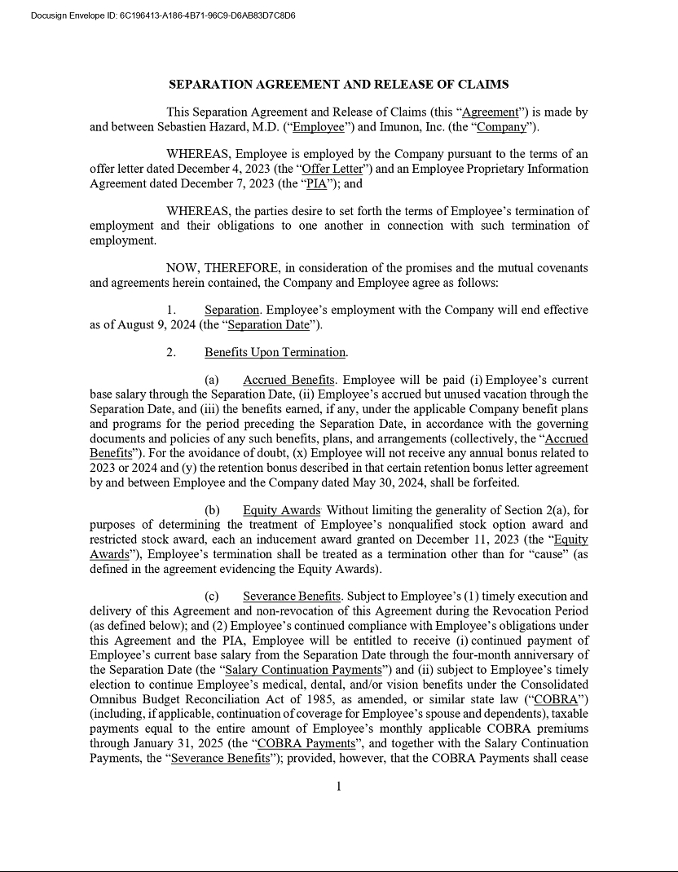

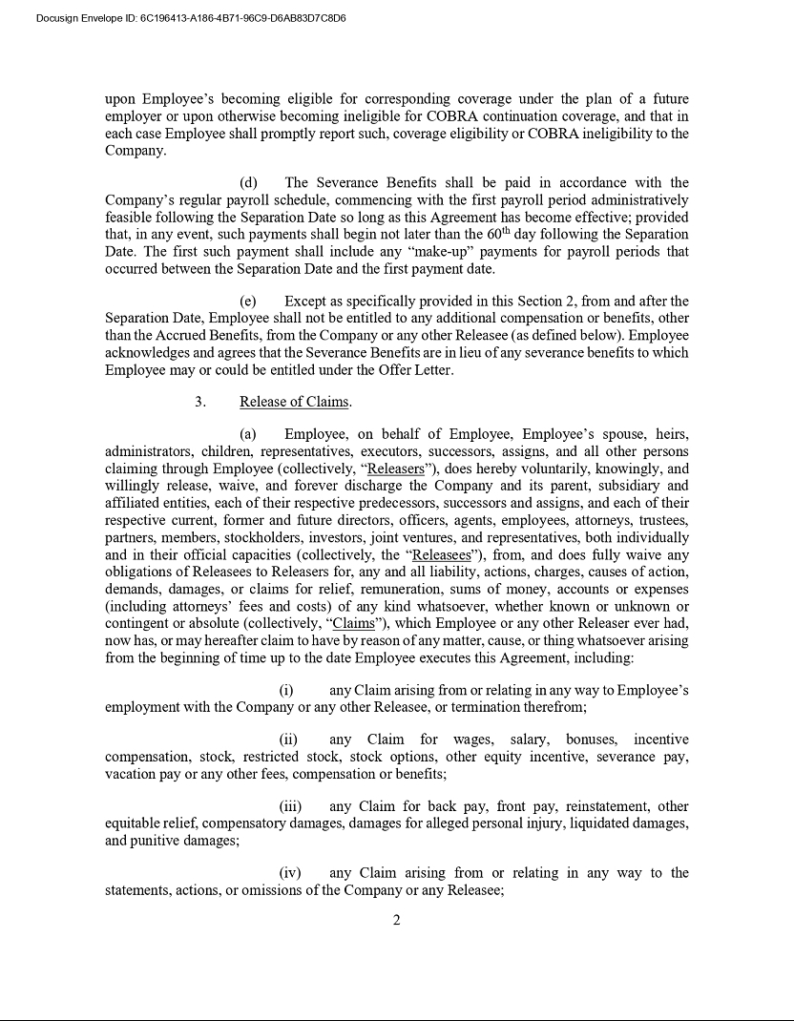

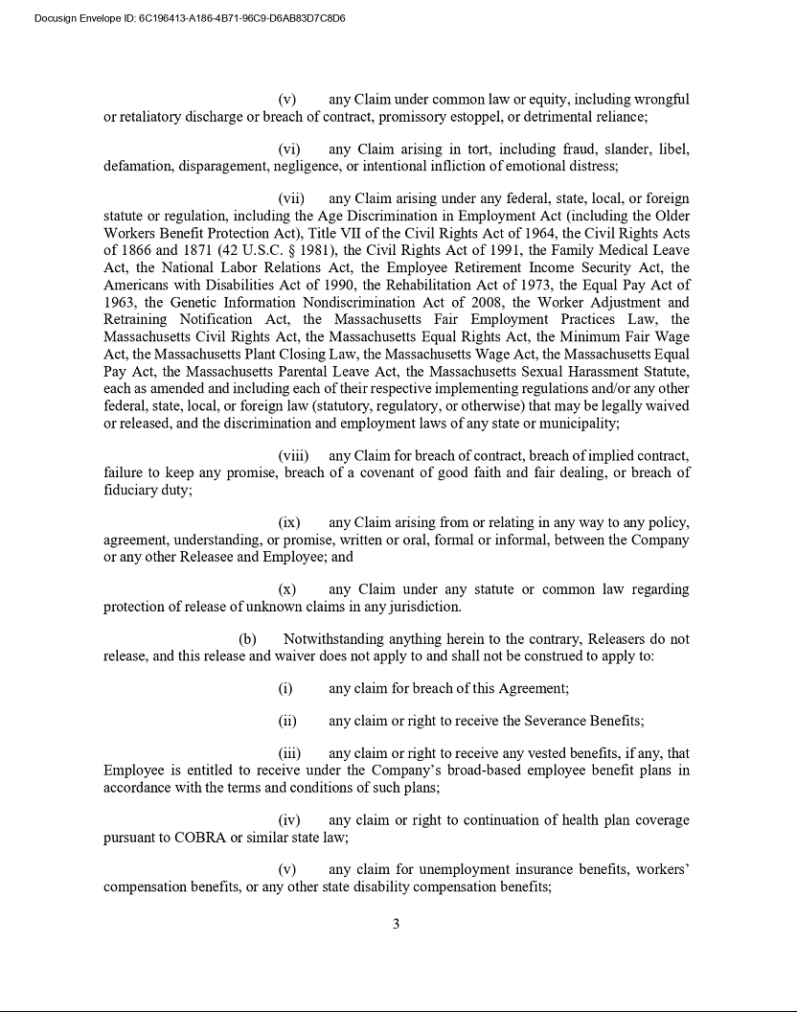

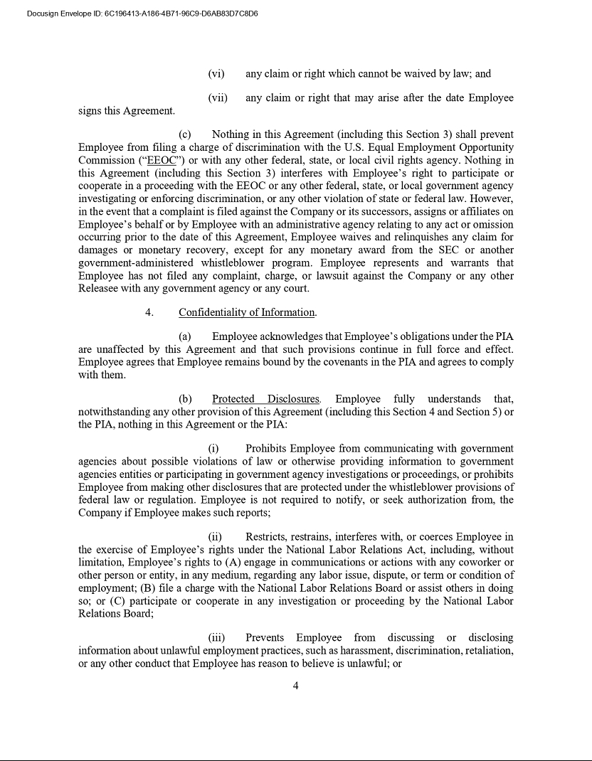

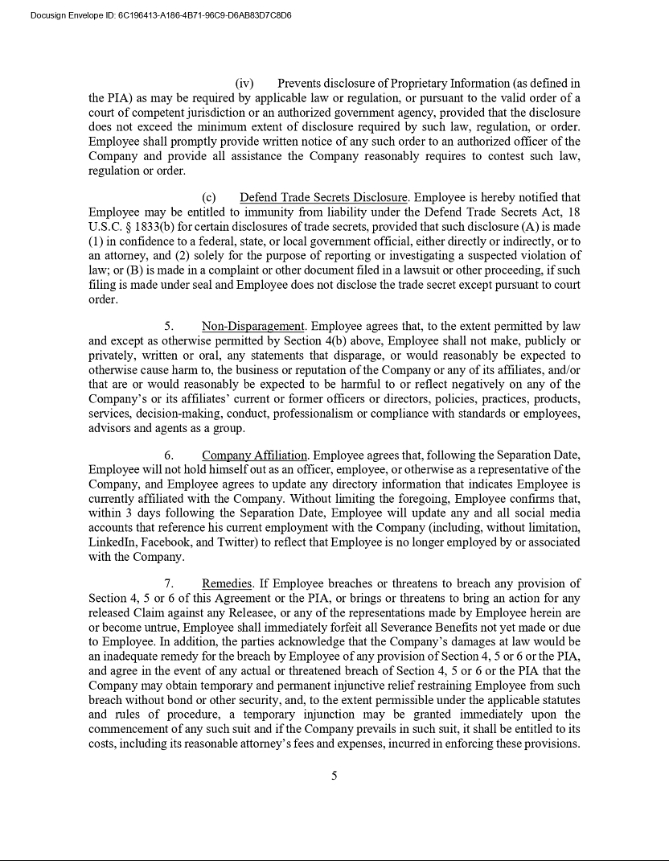

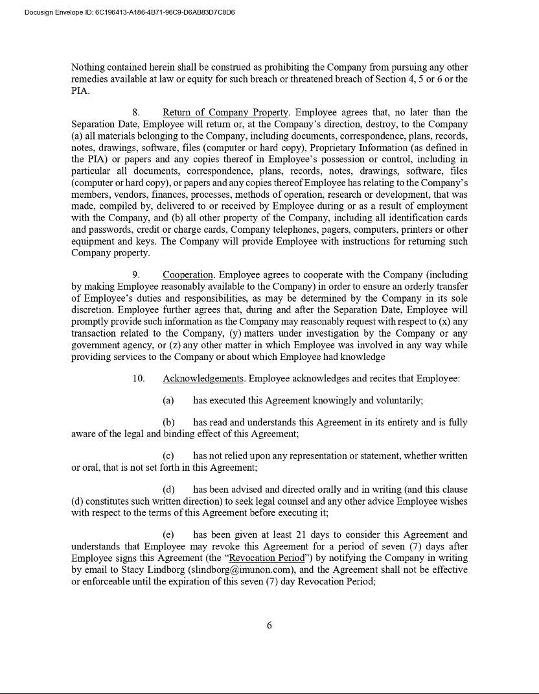

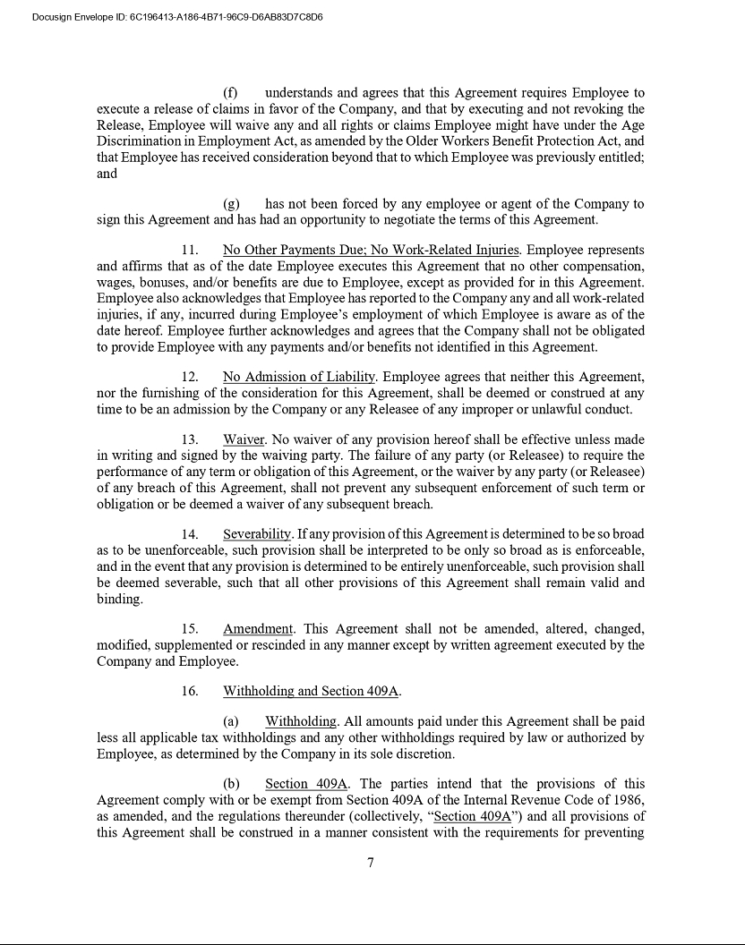

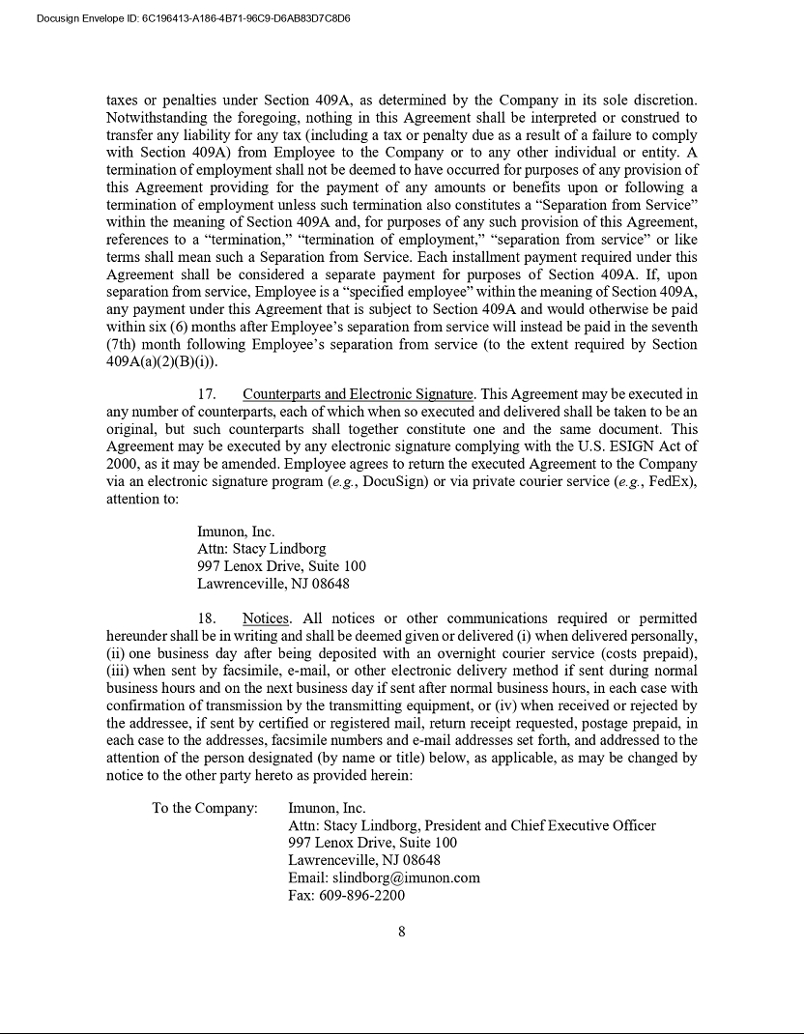

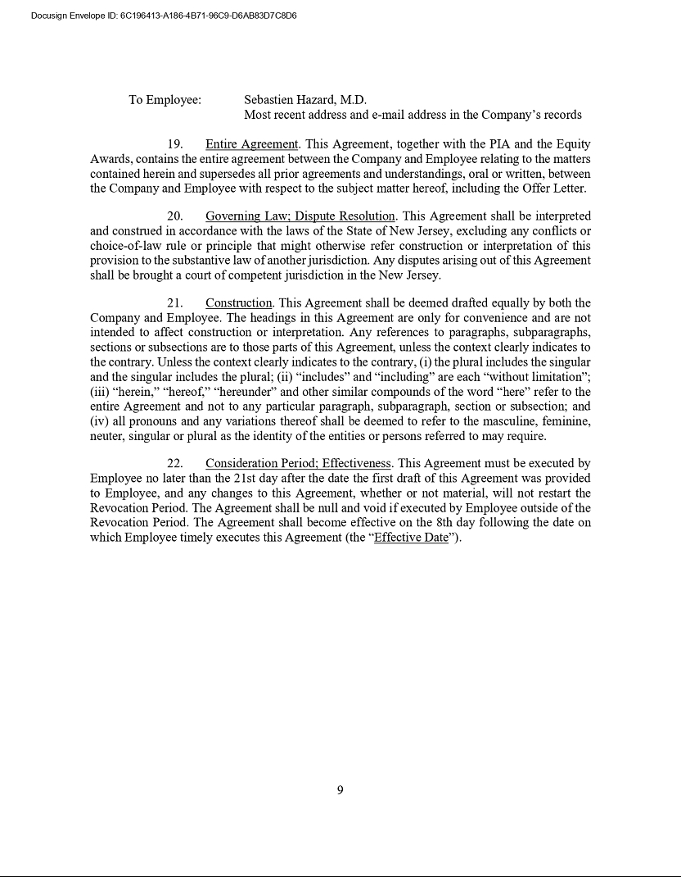

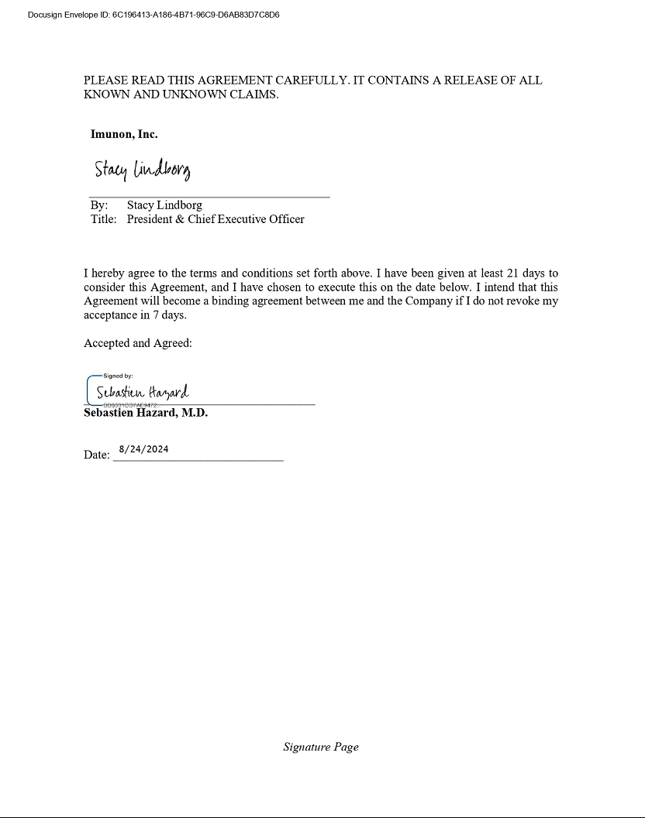

Exhibit 31.1

IMUNON, INC.

CERTIFICATION

I, Stacy R. Lindborg, certify that:

- I have reviewed this quarterly report on Form 10-Q of Imunon, Inc.;

- Based on my knowledge, this report does not contain any untrue statement of a material fact or omit to state a material fact necessary to make the statements made, in light of the circumstances under which such statements were made, not misleading with respect to the period covered by this report;

- Based on my knowledge, the financial statements, and other financial information included in this report, fairly present in all material respects the financial condition, results of operations and cash flows of the registrant as of, and for, the periods presented in this report;

- The registrant’s other certifying officer and I are responsible for establishing and maintaining disclosure controls and procedures (as defined in Exchange Act Rules 13a-15(e) and 15d-15(e)), and internal control over financial reporting (as defined in Exchange Act Rules 13a-15(f) and 15d-
15 (f)), for the registrant and have:

  - Designed such disclosure controls and procedures, or caused such disclosure controls and procedures to be designed under our supervision, to ensure that material information relating to the registrant, including its consolidated subsidiaries, is made known to us by others within those entities, particularly during the period in which this report is being prepared;

  - Designed such internal control over financial reporting, or caused such internal control over financial reporting to be designed under our supervision, to provide reasonable assurance regarding the reliability of financial reporting and the preparation of financial statements for external purposes in accordance with generally accepted accounting principles;

  - Evaluated the effectiveness of the registrant’s disclosure controls and procedures and presented in this report our conclusions about the effectiveness of the disclosure controls and procedures, as of the end of the period covered by this report based on such evaluation; and

  - Disclosed in this report any change in the registrant’s internal control over financial reporting that occurred during the registrant’s most recent fiscal quarter that has materially affected, or is reasonably likely to materially affect, the registrant’s internal control over financial reporting; and

- The registrant’s other certifying officer and I have disclosed, based on our most recent evaluation of internal control over financial reporting, to the registrant’s auditors and the audit committee of the registrant’s board of directors (or persons performing the equivalent functions):

  - All significant deficiencies and material weaknesses in the design or operation of internal control over financial reporting which are reasonably likely to adversely affect the registrant’s ability to record, process, summarize and report financial information; and

  - Any fraud, whether or not material, that involves management or other employees who have a significant role in the registrant’s internal control over financial reporting.

Imunon, Inc.

November 7, 2024 By: /s/ Stacy R. Lindborg

Stacy R. Lindborg

President and Chief Executive Officer

Exhibit 31.2

IMUNON, INC.

CERTIFICATION

I, David Gaiero, certify that:

- I have reviewed this quarterly report on Form 10-Q of Imunon, Inc.;

- Based on my knowledge, this report does not contain any untrue statement of a material fact or omit to state a material fact necessary to make the statements made, in light of the circumstances under which such statements were made, not misleading with respect to the period covered by this report;

- Based on my knowledge, the financial statements, and other financial information included in this report, fairly present in all material respects the financial condition, results of operations and cash flows of the registrant as of, and for, the periods presented in this report;

- The registrant’s other certifying officer and I are responsible for establishing and maintaining disclosure controls and procedures (as defined in Exchange Act Rules 13a-15(e) and 15d-15(e)), and internal control over financial reporting (as defined in Exchange Act Rules 13a-15(f) and 15d-
15 (f)), for the registrant and have:

  - Designed such disclosure controls and procedures, or caused such disclosure controls and procedures to be designed under our supervision, to ensure that material information relating to the registrant, including its consolidated subsidiaries, is made known to us by others within those entities, particularly during the period in which this report is being prepared;

  - Designed such internal control over financial reporting, or caused such internal control over financial reporting to be designed under our supervision, to provide reasonable assurance regarding the reliability of financial reporting and the preparation of financial statements for external purposes in accordance with generally accepted accounting principles;

  - Evaluated the effectiveness of the registrant’s disclosure controls and procedures and presented in this report our conclusions about the effectiveness of the disclosure controls and procedures, as of the end of the period covered by this report based on such evaluation; and

  - Disclosed in this report any change in the registrant’s internal control over financial reporting that occurred during the registrant’s most recent fiscal quarter that has materially affected, or is reasonably likely to materially affect, the registrant’s internal control over financial reporting; and

- The registrant’s other certifying officer and I have disclosed, based on our most recent evaluation of internal control over financial reporting, to the registrant’s auditors and the audit committee of the registrant’s board of directors (or persons performing the equivalent functions):

  - All significant deficiencies and material weaknesses in the design or operation of internal control over financial reporting which are reasonably likely to adversely affect the registrant’s ability to record, process, summarize and report financial information; and

  - Any fraud, whether or not material, that involves management or other employees who have a significant role in the registrant’s internal control over financial reporting.

Imunon, Inc.

November 7, 2024 By: /s/ David Gaiero

David Gaiero

Chief Financial Officer

Exhibit 32.1

IMUNON, INC.

SECTION 1350 CERTIFICATIONS*

Pursuant to the requirement set forth in Rule 13a-14(b) of the Securities Exchange Act of 1934, as amended (the “Exchange Act”), and Section 1350 of Chapter 63 of Title 18 of the United States Code (18 U.S.C. §1350), each of the undersigned hereby certifies that, to the best of his or her knowledge, (i) the Quarterly Report on Form 10-Q for the period ended September 30, 2024 of Imunon, Inc. (the “Company”) filed with the Securities and Exchange Commission on the date hereof fully complies with the requirements of Section 13(a) or 15(d) of the Exchange Act and (ii) the information contained in such report fairly presents, in all material respects, the financial condition and results of operations of the Company.

November 7, 2024 By: /s/ Stacy R. Lindborg

Stacy R. Lindborg

President and Chief Executive Officer

November 7, 2024 By: /s/ David Gaiero

David Gaiero

Chief Financial Officer

- This certification accompanies the Form 10-Q to which it relates, is not deemed filed with the Securities and Exchange Commission and is not to be incorporated by reference into any filing of the Company under the Securities Act of 1933, as amended, or the Exchange Act (whether made before or after the date of the Form 10-Q), irrespective of any general incorporation language contained in such filing.

